**ASAP METHODOLOGY**

**ASAP Methodology is a road map for implementation, we have 5 phases in ASAP methodology.**

1. **Project preparation: in this phase we can decide how many people are going to be part of**

**this implementation project like that.**

1. **Blueprint: what exactly blueprint means it is final document based on requirement gather from the Clint, in this phase first we need to get the ASIS document from Clint (current stage of business process) and we musts provide TOBE document like what all things we are going to configure, the difference between ASIS and TOBE is called GAP.**
2. **Realization: In this third phase we are going to configure all thing what ever mentioned in Tobe document, and configuration testing and integration will also involve in this stage.**
3. **Final preparation: in final preparation we have few activities like**

* **User acceptance test**
* **Cutover activity (data upload activity)**
* **End user training**
* **Preparing training manuals**
* **Configuration document**

1. **GO Live: in this phase system is ready to record the live transitions,**

**Post implementation all sap related to errors activities will come under support team**

**Functional specification: Functional specification consist of enhancement related requirements like what is the problem statement, what we are going to develop and as a functional consultant what we are going to do and what ABAP people will do this all details we should mention.**

**Explain Cutover Activities/Strategies in SAP FI.**

**Cutover Activities or Master Data Uploading Strategies Depending upon the when we are going live. As per that, you have to give the information to your core team. If you are going live at the middle you have to upload the all P&L Account items and B/S Items. If you are going live at the financial year start, you have to only Upload the B/S Items. Activities for go lives**

1. **G/L Master Upload Thru BDC or LSMW (TC-Fs00 and extended one co code to another company code Fs01)**

**2. Vendor Master Upload Thru BDC Or LSMW (Will be Taken Care By MM)**

**3. Customer Master Upload Thru BDC or LSMW (Will be Taken Care By SD)**

**4. Asset Master Upload(Thru As90)**

**5. Cost Element Master Upload**

**6. Cost Center Master Upload**

**7. Profit Center Master Upload**

**8. G/L Balances Thru F-02**

**10. Vendor Balances thru F-43**

**11. Customer Balances thru F-22**

**12. Customer Advances thru f-29**

**13. Vendor Advances through F-48**

**Before uploading Vendor Balances you have to take care of WHT(TDS) Information.**

**we have to upload first the Master such as G/l Accounts , Primary Cost Elements & Secondary cost elements. then upload the open items , then p/l balances, then B/S balances , finally asset master with balances**

**Activate Methodology**

**Stages in Activate Methodology:**

**SAP Methodology consists of Discover, Prepare, Explore, Realize, Deploy & Run phases.**

**SAP Activate – Discover(Discover value of SAP S/4 Hana)**

* **This Discover phase will help you consider and experience SAP S/4HANA before starting a project to implement SAP S/4HANA.**
* **In this phase, you develop strategies and road-map you use on the implementation journey. This implement recognises benefits and values.**
* **Experience SAP S/4HANA with preconfigured SAP Best practices-based Cloud and On-premise trials.**

**SAP Activate – Prepare (plan, prepare and start the implementation project)**

* **Project is initiated and planned, including quality and risk plans.**
* **System environment is set up, including best practices with ready to run processes.**

**SAP Activate – Explore (Define all details)**

* **Customer team explores SAP solution functionalities while the system integrator explores customers business.**
* **Together, they use fit/gap workshops to identify the configuration and extensions that best meet the customers’ requirements.**

**SAP Activate – Realize(implement technical and functional changes)**

* **Together, teams configure and extend the system based on prioritized requirements captured in explore phase**
* **Configuration and build are done in iterative cycles with regular validations and feedback from business**
* **Structured testing and data migration activities help ensure quality.**

**SAP Activate – Deploy ( prepare to go live)**

* **Final preparations before cutover to production help ensure that the system data and users are ready for transitioning to production environment.**
* **The transition to operations includes setting up and launching support, then handing off operations to the organization managing the environment.**

**Enterprise structure & global settings in-depth details.**

* **Fiscal year variant: FV decide that which fiscal year is company is using to prepare the financial reports weather calendar year or non-calendar year**

**Year shift: system does not know what the broken fiscal year is**

* **Posting period: posting periods controls the posting of transaction for a specific period**

**Normal posting periods are used to post day to day company Transactions, and special periods are used for Adjustments and auditor’s rectification entries.**

* **Field status variant: fv is bunch of field status groups which is link with gl master and it will help to control the fields which is appearing during transaction posting,**
* **Posting key: posting key will decide the transaction type credit and debit side of transaction and also it is posting key will control the fields which is appearing during transaction posting,**

|  |  |  |  |  |  |
| --- | --- | --- | --- | --- | --- |
| **Customer** | **01-09** | **Debit** | **11-19** | **Credit** |  |
| **Vendors** | **21-29** | **Debit** | **31-39** | **Credit** |  |
| **GL** | **40** | **Debit** | **50** | **Credit** |  |
| **Asset** | **70** | **Debit** | **75** | **Credit** |  |
| **Stock initial entry** | **80** | **Debit** | **90** | **Credit** |  |
| **Price difference** | **83** | **Debit** | **93** | **Credit** |  |
| **Consumption** | **84** | **Debit** | **94** | **Credit** |  |
| **Change in stock** | **85** | **Debit** | **95** | **Credit** |  |
| **GR/IR** | **86** | **Debit** | **96** | **Credit** |  |
| **Stock inward movement** | **89** | **Debit** | **99(Stock outward movement)** | **Credit** | **Material** |

**For special GL posting key we need to select the special gl option**

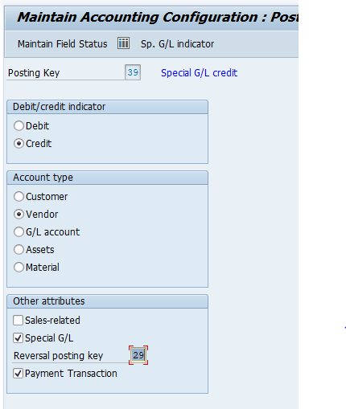

* **Tolerance group/ Tolerance limit: TG refers to the employees do not exceed their limits.**
* **Document type: DT determine type of the transition asset, vendor, customer (invoice, credit, payment) it will control number range**

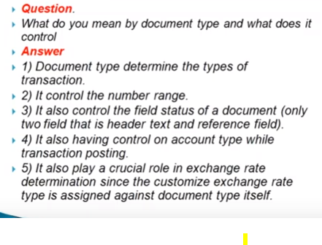

* **Copy number range previous financial year to current financial year :OBH2**

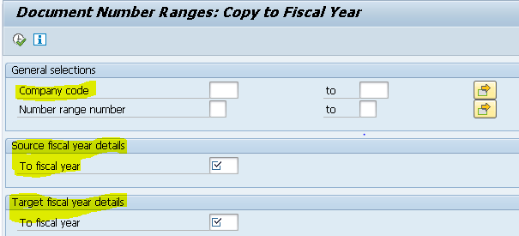

* **Copy number range one company code to another company code : OBH1**

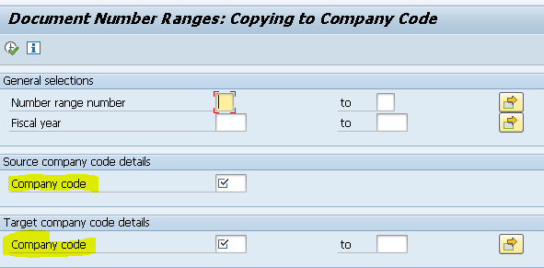

**Clint level settings examples:**

* **Document type**
* **Posting key**
* **Customer/vendor account group**
* **Business area**

**Company:**

**Company in SAP systems is optional. Company is an Independent organizational element whit' is required to consolidate two are more company codes data at country level or segment level or continental level. Under Group Company, you generate consolidated financial statements as per requirements of organization.**

**Example: - Reliance Group, Wipro group, etc.**

**Select Account Type −**

* **Valid for all account type (masking)**
* **A = Asset**
* **D = Customers**
* **K = Vendors**
* **M = Materials**
* **S = General Ledger Account**

**Fiscal year variant:**

**Year independent: the same number and date for the periods for every year : k4 Ex: January to December**

**Year dependent: periods can vary from year to year.V3**

**EX: April to march**

**Shortened fiscal year: the company which windup in December only is called SFY.**

**Normal posting periods are used to post day to day company Transactions, and special periods are used for the purpose of Adjustments and auditors rectification entries.**

**Filed status variant:**

* **We have to use when gl creation.**
* **There are 4 option on this variant.**

1. **Suppers –hide**
2. **Display**
3. **Optional**
4. **Required mode**

**What is Field Status Group in SAP**

**During document entry, field status group controls which fields are required for entry and which fields are set to optional and suppress. The field status groups are available under field status variant and it will be assigned to company codes in SAP.**

**Document types:**

**K: vendor**

**D: customer**

**M: material**

**S: GL**

* **KR: Posting vendor invoice**
* **KZ: Vendor payment document type**
* **RE: Vendor payment document type**

**(KZ document is posted to the vendor account out of FBCJ (Cash journal) and RE is created via MIRO. So we are selecting both these documents in a single Payment Proposal (F110). This payment proposal is not combining both the document types to give us a single combined value to be paid to the Vendor. Instead it is showing two line items one for the total of RE and another for the total of KZ)**

* **ZP: Automatic payment program.**

**Tolerance settings**

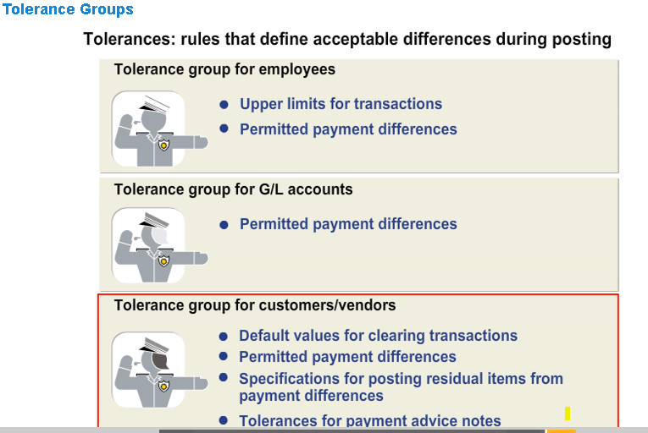

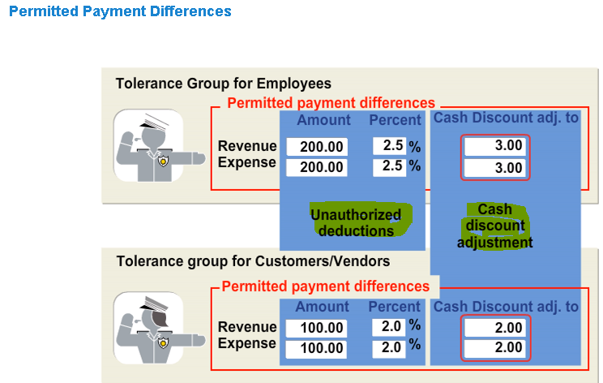

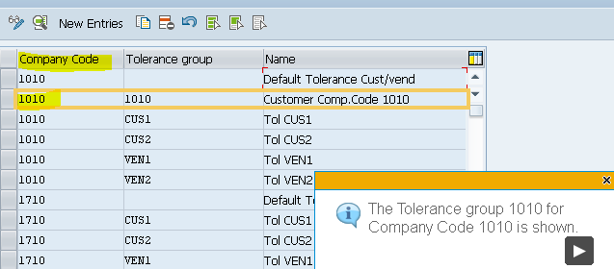

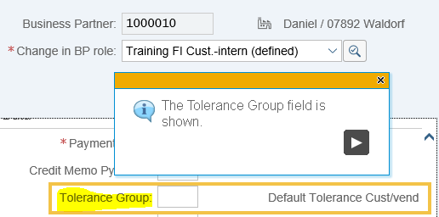

**We have to create the tolerance group and assign to company code as well as master data( vendor or customer) in company code tab payment transaction we can see tolerance group field**

**Payment terms**

* **Maximum two discount only we can give**
* **Payment can block through payment terms & default payment method also we can get through payment terms**
* **Day limit is like example whatever invoice posted till 15th of months it has to pay 15th of that month and after 16th posting should pay on 31st of month, this case we will use day limit**

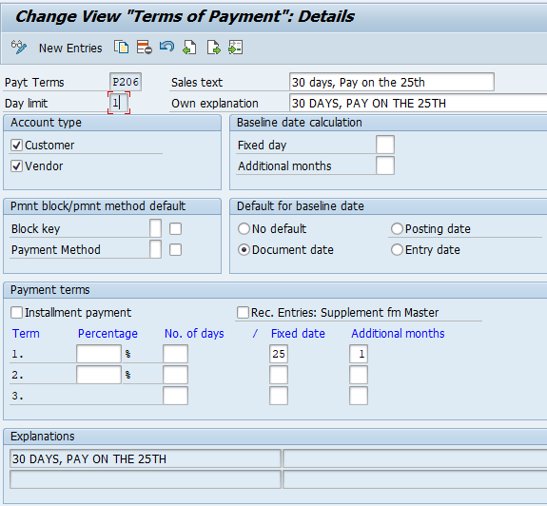

**GL Account**

**Chart of account: Chart of account is a list of gl accounts, A company might have thousands of different accounts in their book of accounts , if we want generate any financial report we have to enter all gl account instead of the to make work easy we are using chart of account.** Assign **chart of accounts to company code**

**Accounting group: Account group is nothing but similar nature of gl accounts club into single group, and it will control the fields which is appearing in the master data, And also it will control the gl number range,** **Account groups are created under chart of accounts, General ledger accounts are created under account group**

**Retained earnings account: it is used to carry forward all P&L statement account balance.**

**Balance carry forward involves carrying forward account balances into the new fiscal year. The balance to be carried forward is shown in the account balance display. To carry forward balances**

**To maintain retained earning account use** **OB53 Tcode**

**Balance Sheet Accounts and Customer/Vendor Accounts The balances on these accounts are carried forward to the same accounts in the new fiscal year. Additional account assignments are transferred.**

**Profit and Loss Accounts**

* **P&L accounts are carried forward to one or more retained earnings accounts. The balances of the profit and loss accounts are set to 0.**
* **Additional account assignments are not transferred.**
* **Transaction currencies are no longer applicable and are summarized in local currency.**

**Showing this retained earning balances in balance sheet under Liability > share holders equity > retained earning** Income/Loss

**GL creation important fields and use:**

* **Account group: Account group will control the fields in gl mater data like which fields are required and which fields are not, and it will control gl number range**
* **Treading partner: Trading partner is your business partner.**

**(Trading partner is your business partner within Group with whom you are doing business, In order to identify Inter Company transactions Trading partner field is used.**

**You need to define all the Group Companies as company in SAP and all the defined Companies will be available for selection in Trading partner field.**

**Trading partner can be defaulted in GL, Customer or Vendor Master. If you need you can populate trading partner at Document level too by doing settings in Document Type Master in T Code OBA7.**

**Using Trading partner, the intercompany transactions gets eliminated in the consolidation.**

* **Account currency: The currency of the account, if the account currency is same as company code currency we can post document in different currencies also, if not the document currency must match with account currency.**
* **Only balance is local currency: If this field is flagged, any document currency can be used with this account, but the document currency is immediately converted to the local currency**
* **Exchange rate difference key:** **This key will specify where exchange rate variances should be posted to. This key may not be necessary for exchange rate differences depending on the configuration**
* **Tax category: The tax category will enable the entry of a tax code on postings to this account (even though if we are selecting both tax category and post without tax allowed option, first priority will be tax category)**
* **Alternative account number: Alternative account number is the account number from your legacy system or the account number from a country chart of accounts if your corporate group uses a standard chart of accounts.**
* **Recon account:** **A reconciliation account is used to show the balance that is supported by a sub ledger. These accounts cannot be posted to. For instance, if the account is a recon account for customers, then inside of AR, the total sum of the customer postings should match that of the GL account.**
* **Tolerance group:** **Tolerance groups assign the maximum percentage or absolute amount that can be written off during open item clearing.**
* **Open item management: this flag should be set for any clearing accounts are offsetting accounts,** **this flag should be set for cash reconciliation accounts, grir accounts and any other clearing accounts. It should not be set for reconciliation accounts.**
* **Line items display:** **This indicator enables display of the account's line items.**
* **Sort key:** **The sort key controls how the assignment/allocation field is populated.**
* **Field status group:** **The field status group controls what fields are required, optional, and hidden per account.**
* **Post automatically:** **If this field is set, the account cannot be posted to via manual transaction.**
* **House bank:** **The house bank account will assign the GL account to a house bank account. This field should be set for the confirmed cash account related to a house bank account.**

**Accounts payable**

**Withholding tax:**

* **Check** **withholding tax countries: we must defined under which country we are going to deduct the TDS**
* **Define withholding tax key: under which section we are going to deduct TDS we have to define.**
* **Define withholding tax type for invoice posting: how withholding should calculate whether gross or net amount and what should be the rounding rules.**

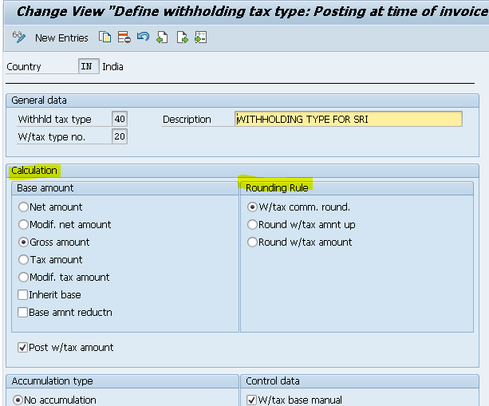

* **Define Withholding Tax Type for Payment Posting**

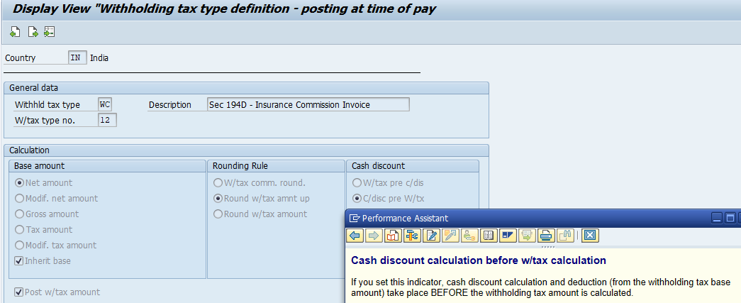

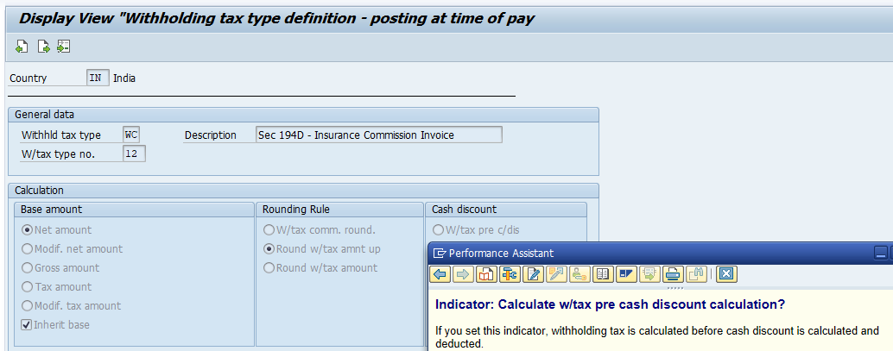

**We have two types of withholding tax type one is WHT tax type for invoice posting and second one is WHT tax type for payment posting, but we can see cash discount option only in payment posting**

* **Define withholding tax code**

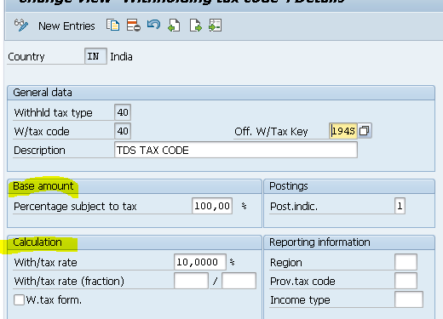

* **Assign withholding tax type for company code**
* **Activate extended WHT**
* **Define account for withholding tax to be paid o ver**

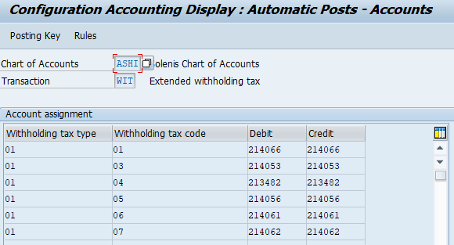

**Entries for WHT**

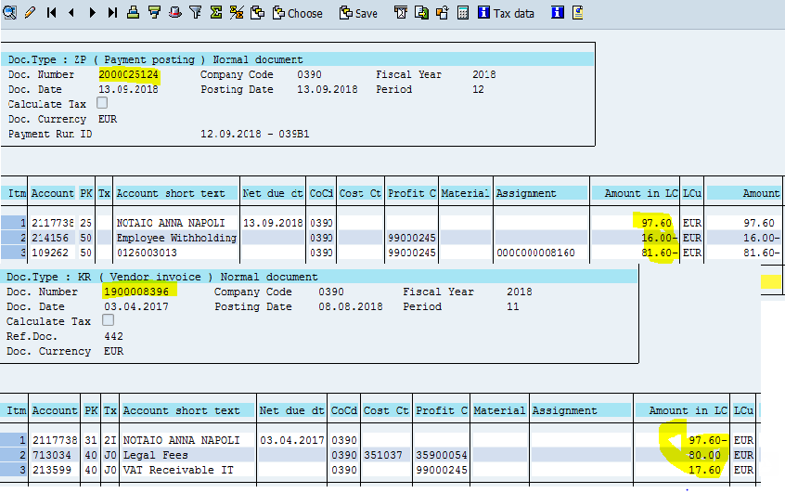

**At the timing of posting the invoice WHT entry**

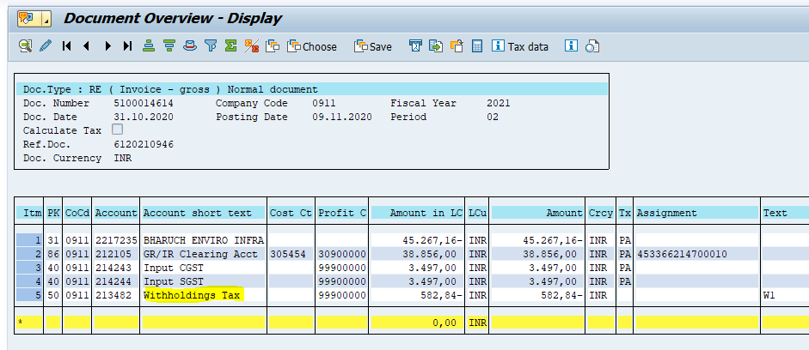

**How to change withholding rates: based on the exemption percentage on the vendor master data we can change the WHT rates, we have to maintain exemption reason and number here**

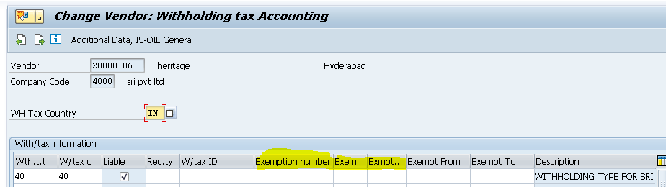

**One of the difference between classic and extended withholding taxes is that in classic withholding tax you can enter only one line item in the vendor master record whereas in extended you can have multiple line items .Secondly classic is for creditors(Creditors are an Account Payable and reside under current liabilities in the Balance Sheet.) whereas extended is both for customers as well as vendors. What we mean by multiple line items means is if you  
want to see separately tax ,surcharge &Ecess**

**How to link discount gl : OBXU**

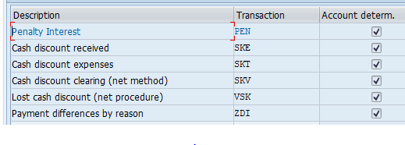

These accounts are defined in below transactions:

OBXI

Cash discount expenses

OBXU

Cash discount received

in this case during Invoice verification (MIRO), you can enter the discount value against the material in the Material Tab. So actually this would not be accounted in any GL if the intention is to adjust the material valuation.

The material tab needs to be activated thro SPRO settings.

The example below would help you in understanding.

**MIGO**

Material ABC      Dr      100

GRIR                 Cr       100

**MIRO**

GRIR      Dr      100

Vendor           Cr     90

Material ABC  Cr     10

**Cash discount entry will fall at the time of payment entry (f110) only , while posting invoice cash discount entry will not come.**

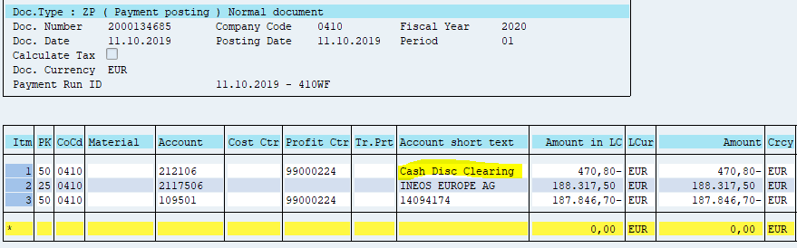

**Down payment entries:**

Accounting postings for typical vendor down-payment process would be as follows*:

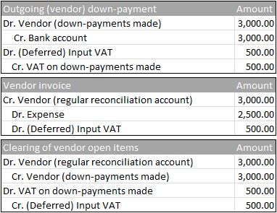

Accounting treatment for incoming down-payments is similar:

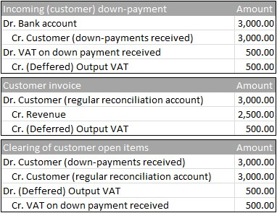

Deferred output and input VAT GL account configuration:

FBKP- Down payment

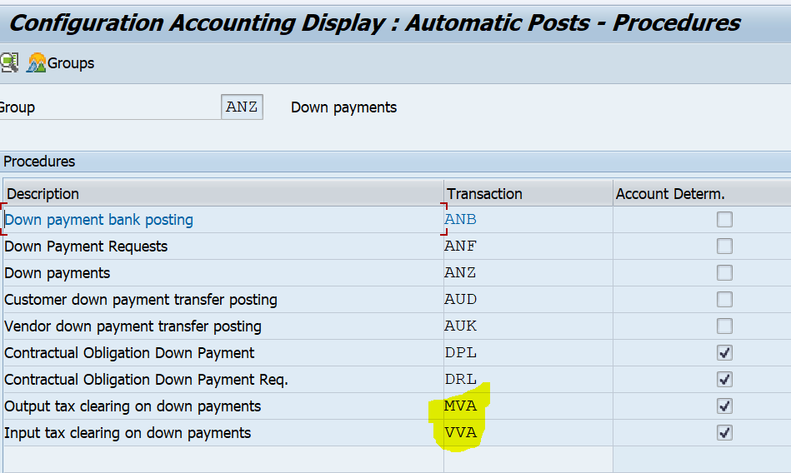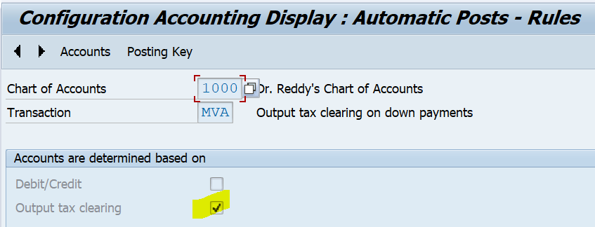

**S/4 HANA BP process flow:**

**Step-: Create the vendor and customer account group**

**Step-2 : Define number range and assign number range to account group**

**Note: if we want BP number and customer and account number is same then we should create number range as external**

**Step-3: Define BP roles, as we already have sap provided roles hence no need to create new ones**

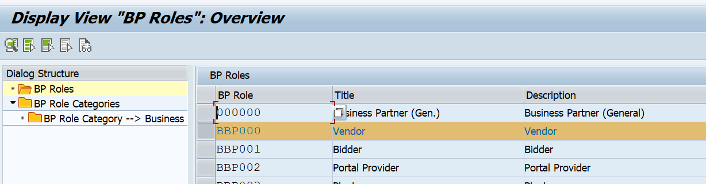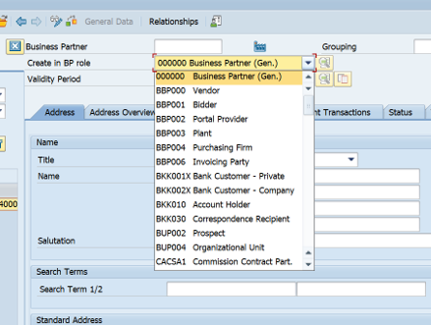

**Step-4:** **Define** **BP grouping and assign number range to BP grouping**

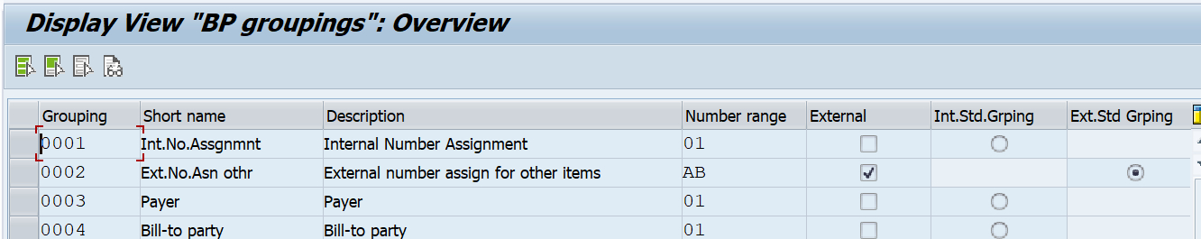

**Step-5 :** **master data synchronization : assign customer or vendor account group to BP group.**

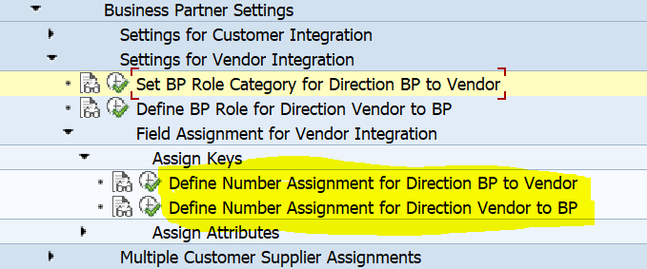

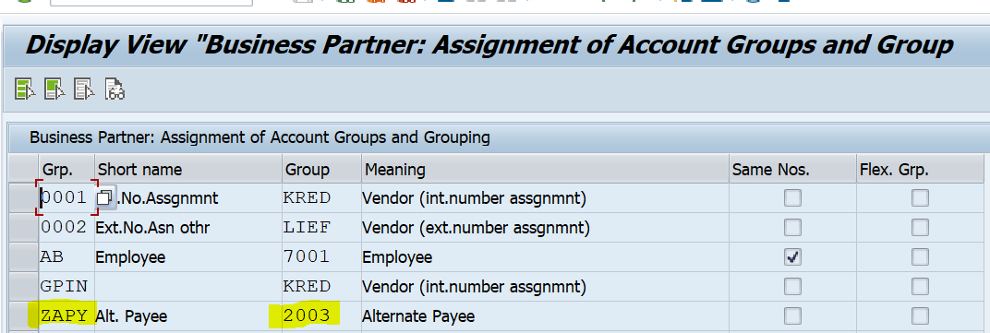

**Vendor to bp assignment supposed to done on migration**

**Step-6: BP role for customer and vendor**

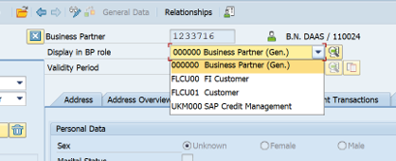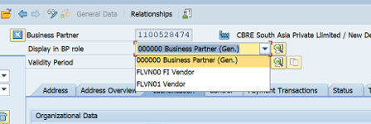

Procure to pay:

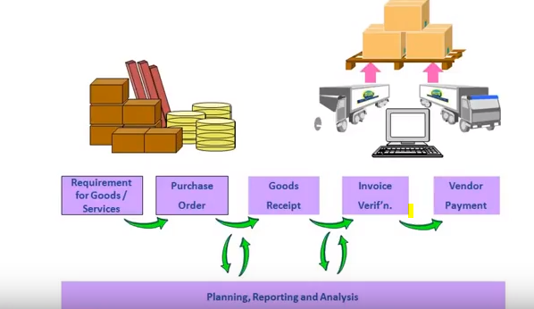

**Whenever company need any type of material initially they will ask for quotation, based on quotation company will finalise the vendor and send the po, in po we will mention all details about quantity and prise in po, based on po vendor will deliver the goods when we received the goods one accounting entry will generate ( inventory A/C DR to GR/IR A/C), goods will deliver to warehouse and invoice will deliver to finance team, when we post invoice one more entry will generate ( GR/IR A/C DR to Vendor A/C), when the payment is done one more entry will generate (vendor A/C DR to bank A/c).s**

**FI-SD-MM**

We know MM modules means procure to pay process, FI module means financial statement and payment process, SD module means sale to customer process.

Most of the manufacturing business logic is stands for 3 things BUY-MAKE-SALE

It means an organization buy a raw material/product from a vendor, then he makes from this raw material/product to finished material/product, then he sale the finished material/product to a customer.

In that 3 part the 3 module are integrate each other.

**FI-MM Explanation ( T030 table)**

* FI-MM integration is integration between two modules
* Whenever we are doing MIGO and MIRO transaction whatever accounting entry will generate those GL’s are coming from OBYC settings.

FI MM settings are maintained in transaction code OBYC. Within these there are various transaction keys to be maintained like BSX, WRX, GBB, PRD etc. In each of these transaction keys you specify the GL accounts which get automatically passed at the time of entry. Few examples could be: BSX- Stands for Inventory Posting Debit GBB-Stands for Goods Issue/Scrapping/delivery of goods etc PRD- Stands for Price Differences.

* Valuation modifier/ valuation group: valuation modifier is group of valuation areas ( combination of valuation area) Valuation grouping code combines the valuation areas having same business properties for the account determination. This reduces number of entries to be created for automatic account determination for the stock postings.

Valuation area will get determine based on material and combination

**lets say you have two plants and you procure/handle a single material with both plant 1 and plant**

**here you different options for valuation**

**1. you can valuate the material at different prices for both plants or you can have same price for both plants**

**2. you can have different GL accounts for plant 1 and 2 or you can group together plant 1 and 2 to have a single GL account. for this scenario, you have to group together the valuation area(plant) with the help of valuation grouping code(valuation modifier). so you can have same GL account in both the plants. You group together plants/vauation area in OMWD and assign the GL account for this grouping in OBYC.**

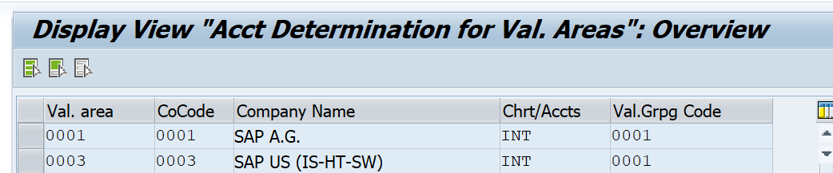

* Valuation class: Valuation class is group of similar types of materials, During obyc settings gl’s are going to assign against some combination, in that combination valuation class also included.

**3000 Raw materials 1**

**7920 Finished products**

**0710 Equipment 1**

**3100 Trading goods**

* Transaction event key: Transaction key which we see in OBYC is determined based on the movement type

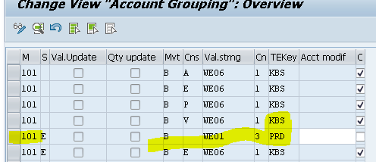

If the business want to post different gl account even though movement type is same or vice versa then it can be done based on account determination

* **Account modification/General modification This key is used to determine different G/L account for the same kind of goods movement based on origin and target.**

**EG: During Goods issue, offsetting G/L is determined from transaction key GBB. If business wants to post to different G/Ls for goods issue for cost centers (Movement type 201) and good issues to orders (Movement type 261) for the same material and plant, Account modifier can help here. To understand this better, let us go to t-code OMWN where we define the transaction key and account modification for the movement type.**

**GBB: AUF, AUF, VKA, VAX,** VAY,**VBR,** **VQP,** **VQY**

VAX: For goods issues for sales orders without account assignment object

VAY: For goods issues for sales orders with account assignment object

**PRD:** **PRU, PRA**

* **Movement type: movement type is three digits identification code which determine different types of goods movement.**

**101: goods receipt**

**201: goods issue for a cost center**

**551: goods scrapping**

**601: goods issue for delivery (shipping)**

**For different movement type, the account entry is done via different transaction event key.**

**Transaction key:**

GL account is determined with the help of transaction key.

Below are few examples:

BSX:  Inventory account (helps in determining GL account for inventory)

GBB: inventory offsetting account (helps in determining offsetting GL account of inventory GL account)

WRX: GR/IR clearing account (helps in determining GR/IR clearing account)

PRD: Price difference account (helps in determining GL account for booking any difference in prices)

**For example**

**If any movement type hits the inventory entry then it will hit the BSX transaction event key..**

**If any movement type hits the off-settings entry then its hit the GBB transaction event key.**

**If any movement type hits the provision entry then its hit the WRX transaction event key.**

**If you noticed the transaction key GBB, then you can find the a lots of account modifier are used for various movement type.**

* **Transaction event key: Transaction event key used to determine the gl accounts**

**BSX,WRX,GBB,PRD**

**Moving average price: total value/ quantity( stock)**

**IF we have difference in po and gr where this difference will go**

**If we have difference in gr price and ir price where should difference should post**

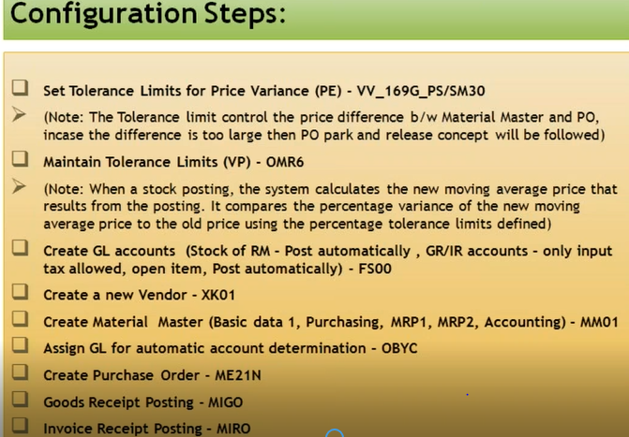

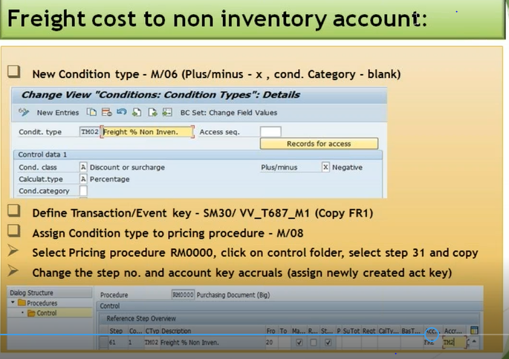

**If we have price difference between po and invoice where difference should post:**

**Ex: po cost is :100**

**Invoice cost is : 110, where 10 difference should post , whenever difference is there it will post on separate gl account, that gl account we should assign to DIF transaction event key.**

**If difference in standard material ( PO AND GR): PRD transaction event key**

**If difference in moving average material ( PO AND GR): it will hit to inventory**

**If DIFFERENCE IN GR AND IR: DIF**

**You can have 2% for your tolerance key.**

**For GR you can set message in t.code: OMC0 for tolerance keys like as B1 ( order price quantity variance ),B2 (order price quantity variance) and VP (variance from moving average price)**

**For IR you can set message in t.code:OMR6 for tolerance keys like as PP (Price variance) ,DQ(Exceed amount: quantity variance) and VP(Moving average price variance)**

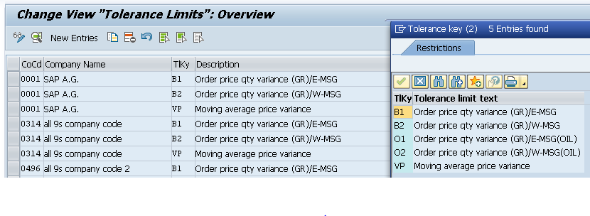

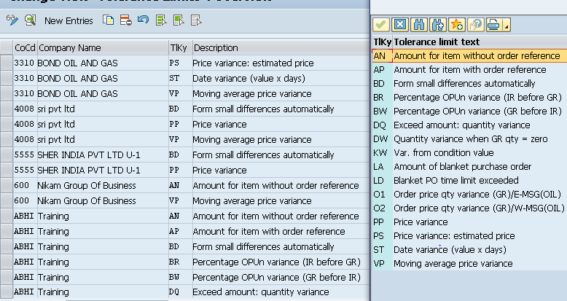

**Normally Price difference with respect to MM happens at the time of GR. The price difference at the time of MIRO (IV) happens in case where the invoice is received for a price different from the PO. For example:**

**In case of a material with Price control as "S" - Standard price**

**PO price - 100Rs.**

**Material Master price - 120Rs.**

**At the time of GR, entry is:**

**Stock account Dr (BSX) 120**

**To Price Difference Account (PRD) 20**

**To GR/IR account (WRX) 100**

**In case of a material with Price control as "V" - Moving Avg Price**

**Same Scenario**

**At the time of GR, entry is:**

**Stock account Dr (BSX) 120**

**To GR/IR account 120**

**Now lets assume that the invoice is received for 130 Rs and we have also accepted the price change, then the accounting entry at the time of MIRO would be**

**In case of a material with Price control as "S" - Standard price (Stock of the material is available or not)**

**GR/IR account Dr 100**

**Price Difference Account Dr 30**

**To Vendor Account 130**

**In case of a material with Price control as "V" - Moving Avg Price (Stock of the material is available)**

**Stock Account Dr 10**

**Gr/IR Account Dr 120**

**To vendor 130**

**In case of a material with Price control as "V" - Moving Avg Price (Stock of the material is not available)**

**Gr/IR Account Dr 120**

**Price Difference Account Dr 10**

**To vendor 130**

**Entries**

**IF po price 100 and gr price is 120 and vice versa in price control S**

**Inventory A/C DR 100 inventory A/C DR 120**

**Price difference DR 20 TO Price difference CR 20**

**TO GR/IR account 120 TO GR/IR account CR 100**

**MIRO posting( if invoice came with higher price and lower price)**

**GR/IR A/C DR 120 GR/IR A/C DR 100**

**Price difference DR 10 TO Price difference A/C 10**

**TO Vendor account 130 TO Vendor A/C 90**

**IF po price 100 and gr price is 120 and vice versa in price control V**

**Inventory A/C 120 Inventory A/C 100**

**TO GR/IR account 120 TO GR/IR A/C 100**

**MIRO posting( if invoice came with higher price and lower price)**

**Inventory A/C 10 GR/IR A/C 100**

**GR/IR A/C 120 TO Inventory A/C 10**

**TO Vendor A/C 130 TO Vendor A/C 90**

**When Freight involved what would be the accounting entry at MIGO and MIRO? What if freight vendor is different?**

**When the freight is involved and the vendor same as po vendor.**

**At MIGO:**

**Inventory A/C**

**TO GR/IR account ( for the total value include freight)**

**At MIRO:**

**GR/IR clearing A/C**

**TO Vendor A/c**

**When the freight vendor is different :** Freight is maintained as planed delivery cost in the po ( either service item or condition type).

No freight accounting in MIGO: when freight is planned delivery cost from separate vendor.

AT MIRO:

Material invoice : from main vendor

GR/IR A/C

To vendor A/c

Freight invoice : from freight vendor

Freight clearing A/c

To vendor A/c

[**Pricing procedure Steps and Details in SAP MM - SAP Community**](https://community.sap.com/t5/enterprise-resource-planning-blogs-by-members/pricing-procedure-steps-and-details-in-sap-mm/ba-p/13087325)

1. Condition Table
2. Access Sequence
3. Condition Type : assigning access sequence to condition type
4. Condition records.
5. Schema Group: schema group for vendor and purchase organisation group we need to maintain and assigning purchase org schema group to purchase organisation

One schema group will be assigned to vendor and one schema group will be assigned to Purchase organization. With this combination, system will fetch the pricing procedure.

1. Calculation Schema: same like tax procedure defining and assigning condition type in calculate schema procedure-

Here we maintain sequence for the pricing calculation, like gross price, discount, rebate, surcharges etc. Here we maintain the calculation for all condition types and group together all required condition types for our pricing procedure.

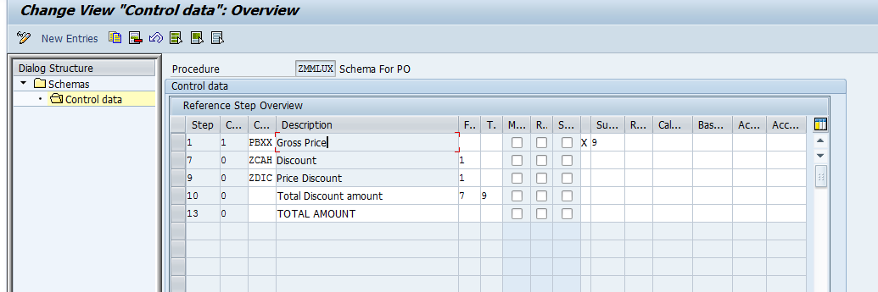

1. Schema Determination: assign purchase organisation schema group and vendor schema group to pricing procedure

(1) Transaction F.13 - this automatically clears any goods receipt and invoice receipt lines that match with each other (using the PO number and line item as a reference). It is good to run this transaction every day or by using a batch job;

(2) Transaction MR11 - this clears off any Goods Receipts that do not have a corresponding Invoice receipt, or Invoice Receipt that does not have a corresponding Goods receipt.

The idea is to have the GR/IR account managed on a consistent basis, otherwise it will be difficult to determine which items are outstanding and need to be addressed.

**What are some standard SAP reports for GR/IR?**

A: I use FAGLL03 and MB5S and also I run MRBR in display mode

**GR/IR clearing account: F.19**

**F.19 GR/IR regrouping**

The GR/IR clearing account records all the goods and invoices received. If the balance of the GR/IR account is not zero on the balance sheet key date, this is because

• Goods were invoiced by the key date but have not yet been delivered or

• Goods were delivered by the key date but have not yet been invoiced

The first case is an example of receivables from the vendor and the second of payables to the vendor. Accordingly, the balance must be displayed separately on either the asset side or the liabilities side.

A special program analyzes the GR/IR account for this purpose and posts the balance to either an invoiced but not delivered” account or a “delivered but not invoiced” account. At the same time, the posting is reversed for the first day of the next period, since this transfer posting would produce incorrect results during the day-to-day activities.

An adjustment account is usually used to clear this entry. The GR/IR clearing account and its adjustment account are contained in the appendix to the balance sheet.

GR/IR Regrouping is carried out for Balance Sheet Reporting during closing. Not running F.19 will impact reporting if there is any balance in GR/IR account (if the balance is zero, there will be no impact). We run F.19 at the end of the period and reverse the same at the start of the next period. Hence, I don't see any impact by not doing F.19

**Transaction F.13** can be used at the period end to clear the GR/IR account **line items** for which previously invoice, or goods were missing.

But it might happen that A/C GR/IR still has some credit and/or debit balances at the end of the month/period.  
i.e. A credit balance for the transactions “**delivered, but not invoiced**” and

a debit balance for the transactions “**invoiced, but not delivered**“.

Now the business is required to display these two above mentioned business transactions correctly in the balance sheet.

That is, credit and debit balance must be taken out from account “**GR/IR**” and reclassified/regrouped correctly.

**Trensaction code : OBYP**

**FBKP > Automatic clearing > Goods/invoices receipt clearing**

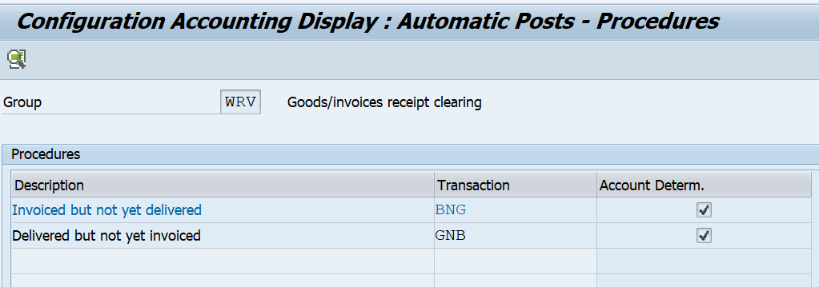

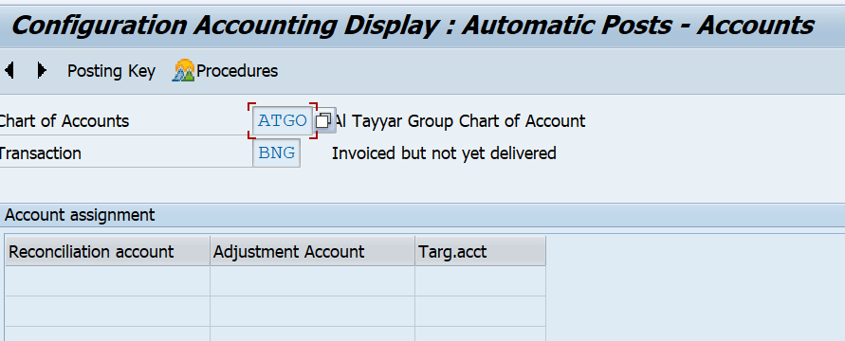

***What configuration is maintained in FBZP and why it’s needed?***

Automatic Payment Program (APP) serves the purpose of posting accounts payable like payment to a vendor based on vendor invoices automatically.

APP is used to find out due/overdue invoices and to process a list of customer and vendor invoices to make payments in one go. APP cannot be used for all company codes from different countries.

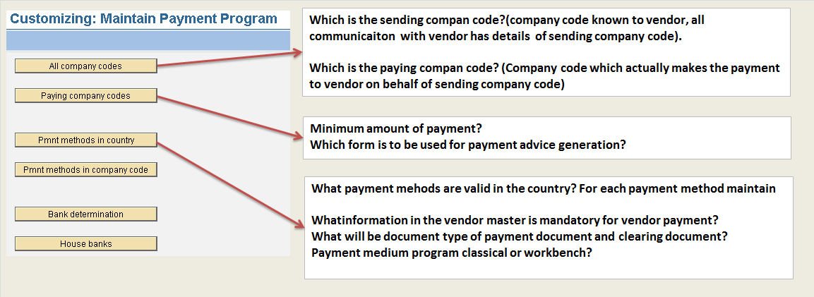

If we go to fbzp transaction code there we can see the six steps to maintain the app configuration, the first step will be all company code in that we have to specify what is the paying company code what is the sending company code and which special gl transaction to be paid, and which special gl transaction should come under exception we have to define, the next step will be paying company code in this what is the min amount to be paid, and which form we are using to send the payment advise we have to specify, the next step will be payment method in country, what payment methods are valid in that country for each payment method what all are fields required in vendor master data to make payment, and what is the clearing document what is paying document type, what is the payment medium whether classic payment medium program or payment medium workbench, and what all are currency allowed for this payment method,

Payment method in company code. out of valid payment methods in country which payment method we are using in company code, for each payment method, what should be the min and max amount and foreign business partner allowed or foreign currency allowed can payment doe foreign vendor,

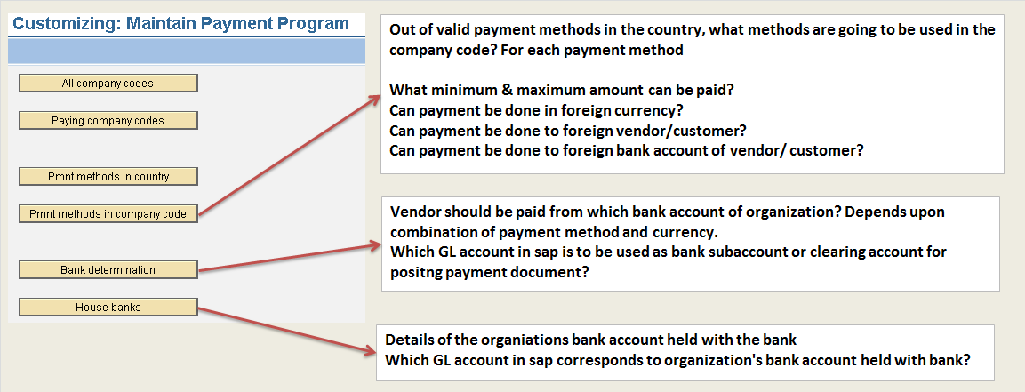

House bank: in this step it will tell you details of organization bank account details and gl account assigned to bank as well as we should assign to Edi partner number and EDI compantable payment methods.

**Sending company code and paying company code entries:**

**Before starting the cross company code transactions we need tosetup few settings**

* **In OBA7 for perticular document type inter company posting option should check.**
* **Cross company code transactions setup need to maintin in** **OBya, like which gl should debit and which dl should credit**

**Imaging that sending company code is 1011 and paying company code is 1009 and post entry in1009 CC**

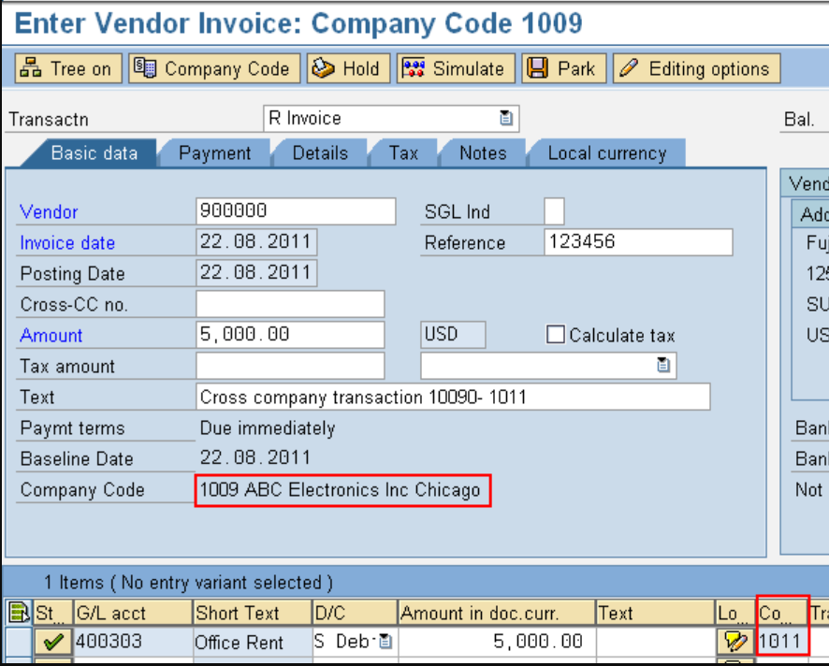

**We can see two document will create and entry should be like below screenshot**

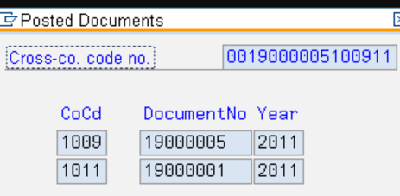

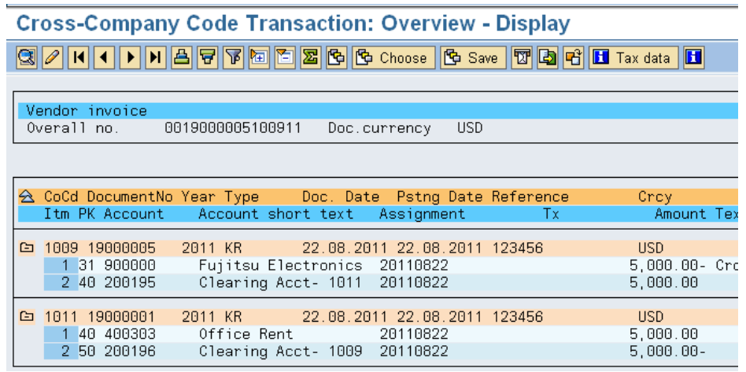

**Alternate account number in FI12** Alternative Bank Acct Number (for Ambiguous Acct Number)

The alternative bank account number is used for differentiate the house bank accounts with identical account numbers. This can occur if a house bank manages accounts in different currencies using the same account number.

The alternative bank account number must then only be defined if it differs from the bank account number. You must maintain it together with the bank key in the system.

If you have house bank accounts with identical account numbers and use the electronic account statement for these accounts, then you enter the internal key used by your house bank here (usually the account number with attached currency encryption). If you use the manual account statement, then you can freely assign the alternative account number. Using bank account number + currency code is, however, recommended.

**Payment order only**

### Indicator: Payment Order Instead of Payment Posting

Means that the payment program does not post a payment document and the paid items are not cleared.

Instead, the system generates and saves a payment order. The information contained in this order can be used to clear the items at a later date.

The payment is posted when it appears on the bank statement, and the relevant open items are selected when the payment order is entered.

The paid items remain blocked for other clearing transactions and further payment runs until the payment has been posted.

**DMEE**

Introduction:  
DME stands for data medium exchange which is used to send payment information of an enterprise to banks or tax authority. Basically these files contain financial data which can be in flat file or xml file format. Different File formats can be created for different countries and different banks based on their own norm which replaces conventional ABAP programs.

If we go to the DMEE t code there we can see the format, Format will be devided in to two partsone is Header and second one is payment details

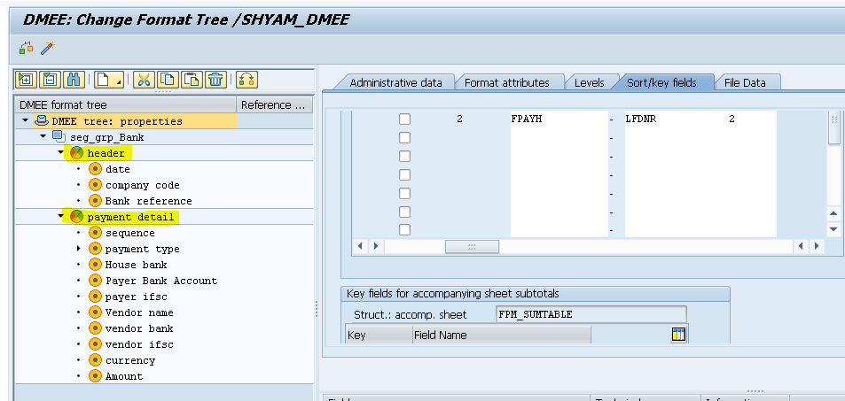

# **Payment medium Work bench and DMEE**

OBPM1, OBPM2, OBPM3 and OBPM4

The Payment Medium Workbench (PMW) is a tool used to configure and create payment media sent by organizations to their house banks. This generic tool will gradually phase out the classic payment medium programs (RFFO*) due to the range of advantages that it provides

**APP** is used to generate the payment orders, which contains instruction on the payment details that your house bank has to perform. Payment mediums especially across different countries can have different structures (i.e. different details of the payment might be required). The most popular structures (e.g. SWIFT MT100) can be supplied by SAP. In cases you have to use the **classic payment medium** **programs** (RFFO*).

However, sometimes you need to generate some specific format of the payment order, which is not supplied by SAP. In this case, you can use **Payment Medium Workbench** (PWM), which can be considered as a workbench that enables you to configure and create custom payment media. PWM is used to define payment medium formats, note to payee etc.

In the Classic Payment Medium you cannot make changes as per business requirements in the payment medium file generated during F110. But in PMW it has the flexibility to define your own payment file format.

Advantages of PMW.

The ability to adapt formats delivered to be customer or bank-specific easily and without modification, including separate selection parameters on the payment medium program.

Simple tools for creating new formats (programming knowledge is not a requirement for using the DME Engine).

**Data Medium Exchange Engine** (DMEE) is a tool that is used in PMW in order to create the fine output (i.e. the text file with payment orders). DMEE can be considered as an independent tool, because it is used not only for payment media generation, but also in other cases (profit tax returns, electronic VAT vouchers etc.).

**AL11 SAP Directories: After running the app the data will store in directory from there based in interface data will reach to banks**

**After running APP based on payment medium the file structure will atomatically convert into bank farmat, After it will store in AL11 directories from AL11 directories it will move to bank directories From here with helf of sterling interface it will pic and send to bank**

**Differece between idoc and dmee**

IDOCs are more standardised and used globally for various internationally accepted formats.

While DME files are more specific to any particular bank or country. You can define the structure of the DME file in customization and can easily modify it without much ABAP knowledge.

**Check payment:**

* **Create the check lot : FCHI (Structure of the check)**

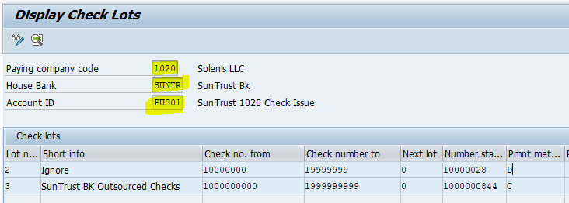

* **Manual check payment : FCH5 (before manual check, check layout should be prepare by the abaper)**

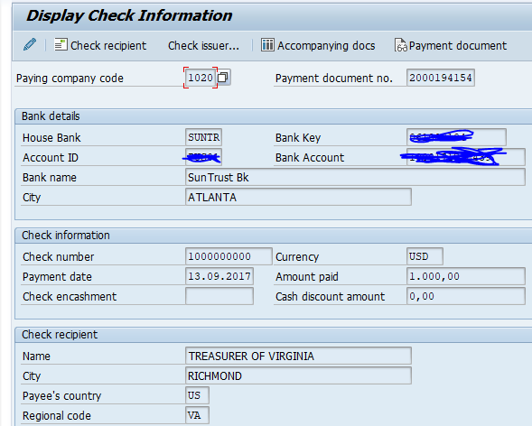

* **Check reversal : FCH9**

Yes it is possible to generate cheque if u run app through f110. You have to customise it in fbzp by going in "payment method in country" and then select ur specific country and payment method then mention payment medium program as "RFFOUS_C".

2nd step is to go to "Payment method in company code" and go to ur respective payment method and put the smart form name in form data.

This will enable you to print cheques when u run app.

u can see ur printed cheques by t-code sp01.

**Accounts receivable**

**FI-SD Explanation (C001,C002 Tables)**

* **Creation of sales order: VA01**
* **Issue the goods (PGI): VL01N**
* **CREATE BILLING DOCUMENT: VF01**

## SAP OTC Sales & Distribution

| **OTC Process Steps** | **Transaction Code** | **Accounting Entries** |
| --- | --- | --- |
| Inquiry | VA11 | No |
| Quotation | VA21 | No |
| Sales Order | VA01 | No |
| Post Goods Issue (PGI) | VL01n | Yes |
| Delivery | VL01n | Yes |
| Billing | VF01 | Yes |
| Receipt of Money | FB50 | Yes |

**Whenever we are posting billing document the entry should be**

**Customer A/c DR**

**To Revenue A/C CR**

**In this entry customer account will picked up from customer master data, All we should know how revenue and discount or surcharge will come into picture.**

**The account determination will happen through VKOA settings, in VKOA we have we have 5 table combinations for assigning the GL account,**

**The system goes about checking for the gl account from more specific criteria to less specific criteria.**

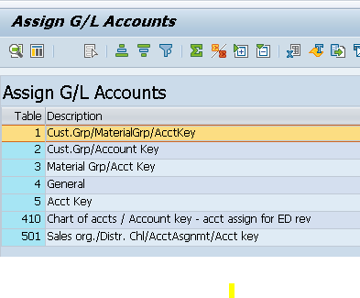

**IF go the table we can see the combination selection to determine gl accounts like**

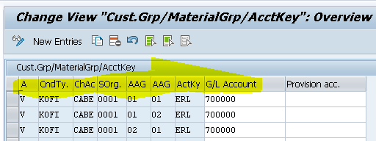

* **.Application key:**

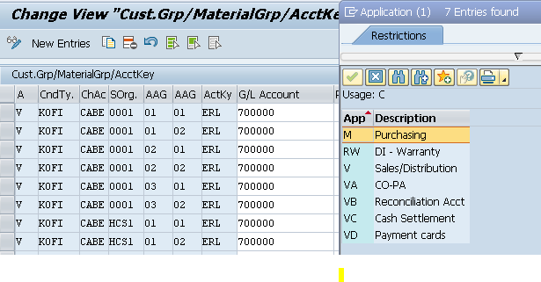

* **condition type**

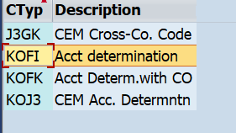

* **chart of account**
* **sales organisation**
* **Customer account assignment group: based on the revenue we have to maintain the account assignment group in customer master data like domestic, foreign, and internal.**

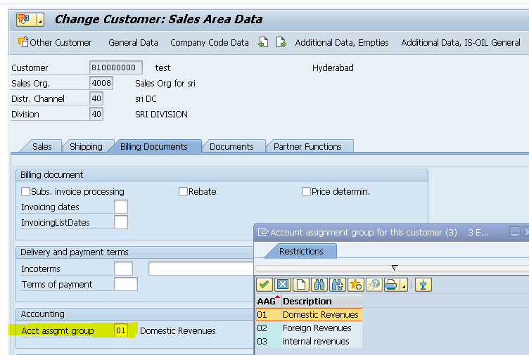

* **Materials account assignment group : in material master data we have to maintain whether this is finished goods are trading like that , based on the this account assignment group we will define the combination.**

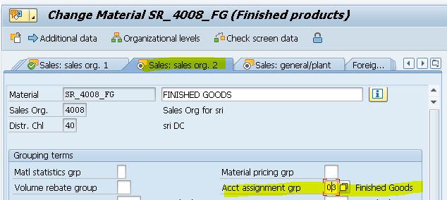

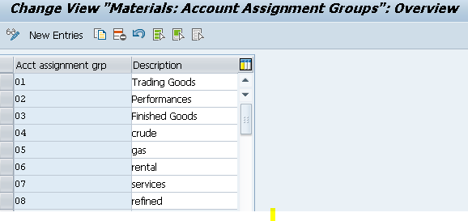

* **Account key : The accounting Key will determine based on the condition type which we are maintained in pricing procedure(v/08).**
* **ERL: price**
* **ERS: discount, surcharge**
* **ERU: Sales rebate accruals**
* **ERB: Rebate sales deduction**

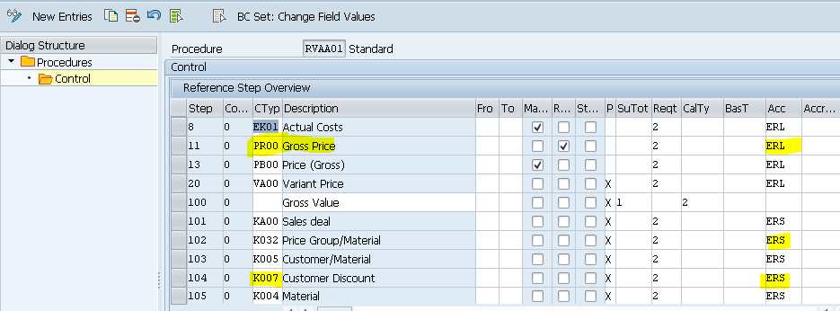

* **Pricing procedure determination in sales docs: OVKK**

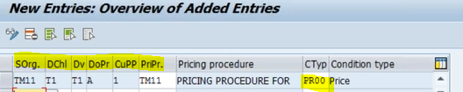

**Initially whenever we are posting billing document to determine the revenue account It will go through first table entry CustGrp/Material grp/ account key. If any Gl account is maintained here the system will take that then go to the transaction data of the particular billing document and see whether such a combination of Customer group and material group exists if it does it will pick that relevant Revenue account and post the accounting document.**

**If it does not it moves to the next combination in the table which is Customer group/account key and so on and so forth Customer grp is maintained in the Sales view of the customer master. Material grp is maintained in the Sales view of the material master. Account key is maintained in the pricing procedure for that condition type.**

**The last option it checks is account key entry. We will now maintain the Gl account for the combination of Material Grp/account key**

**The system will look into this table see this combination and if the relevant combination exists in the transaction it will debit the customer account and credit this account    
As simple as it is. So basically the**[**SAP FI**](https://www.gotothings.com/sapfi.htm)**-SD integration is for picking up the revenue accounts or the discounts and surcharges. The account key determines whether it is revenue or a surcharge or discount.**

**Dunning** 

**When the customer miss the payment for the outstanding invoice within specified payment due date. The dunning letter is generated via sap program and send at customer address for reminding the customer outstanding payment**

**Requirement:**

**The dunning system enables to trace liable customers who have not paid their open invoices within a given time span. It enables you to handle the process from, for example, sending a reminder to customers of their outstanding payments through to referring such customers to collections agencies.**

**The dunning system covers the following documents:**

**1. Open A/R invoices, including invoices that are partially credited or partially paid**

**2. Invoices that include instalments**

**3. A/R credit memos**

**4. Incoming payments that are not based on invoices**

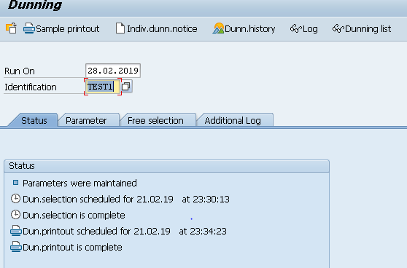

**Define Dunning Procedures**

We can create Dunning text, Dunning level, Dunning Charges and Company code assignment in the dunning procedure

**[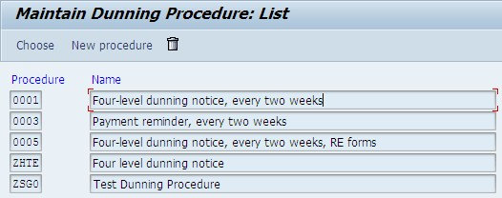](https://blogs.sap.com/wp-content/uploads/2013/05/3_212286.jpg)**

**Create Dunning Interval in days to Dunning Procedures**

We determine at which intervals the allocated accounts are to be dunned for every dunning procedure. During every dunning run, the system then checks whether the run date is at least this number of days (14 days) since the date of the last dunning run. we determine number of dunning level set up in dunning procedure, and grace period for dunning.

[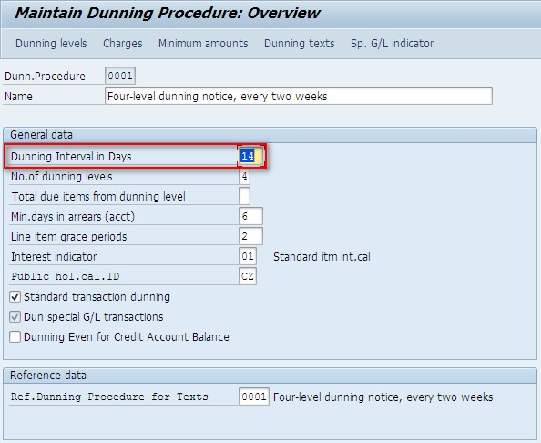](https://blogs.sap.com/wp-content/uploads/2013/05/4_212287.jpg)

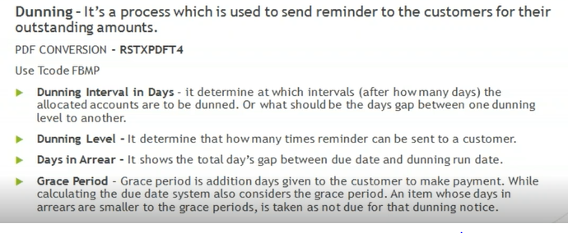

**Define  Dunning Charges to Dunning Procedures**

In this step we add the dunning charge as per the dunning level. This is like an administration charge to dun the customer. Currency Euro is assigned during adding the dunning charge

[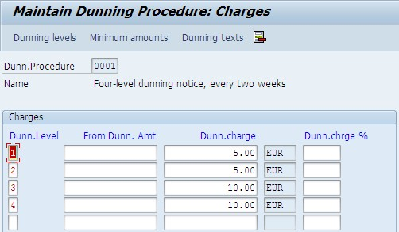](https://blogs.sap.com/wp-content/uploads/2013/05/6_212289.jpg)

**7. Define Minimum Amounts to Dunning Procedures**

Minimum Amount are customized to charge the administration charge to customer with reference to dunning level

[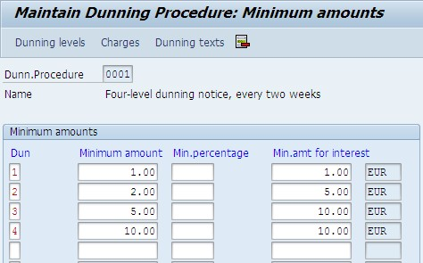](https://blogs.sap.com/wp-content/uploads/2013/05/7_212290.jpg)

**Assign  Dunning Texts and forms  to Dunning Procedures**

For inserting dunning forms, click Dunning Texts and assign the required forms for the dunning text with reference to dunning Level. In case the customer has different language and the form contains different language, then please follow the document attached to translate the source language to target language

[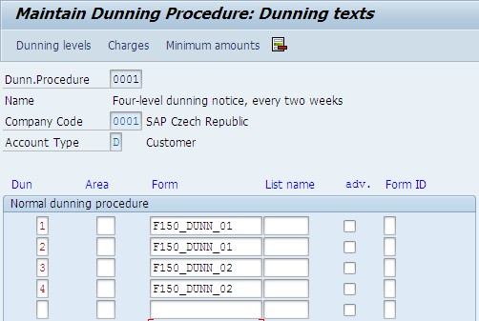](https://blogs.sap.com/wp-content/uploads/2013/05/8_212291.jpg)

**9. Define Dunning level  to Dunning Procedures**

Click the dunning levels and input days in Arrears for each dunning levels.

Select Always Dun in legal dunning proc for not missing any dunning notices.

[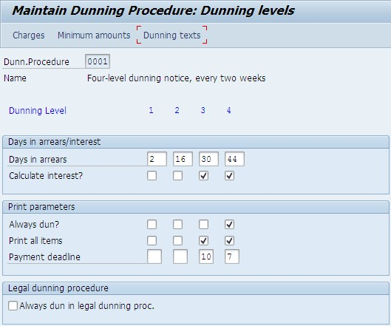](https://blogs.sap.com/wp-content/uploads/2013/05/9_212292.jpg)

**When you are providing goods and services to customer how we can send dunning letters**

**Dunning area: OB61**

Create two dunning areas

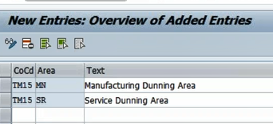

Assign two forms and dunning areas

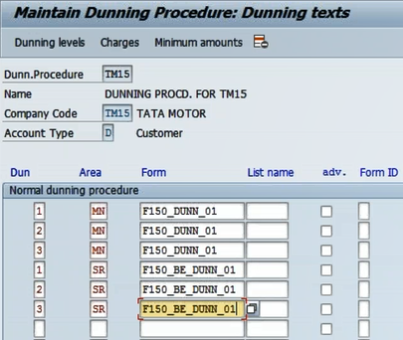

While posting customer posting we should manually select

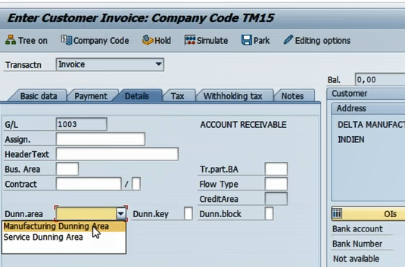

If we want dunning are come to automatically we should assign dunning area in below combination

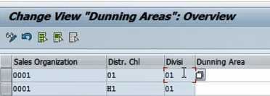

**Order to cash flow**

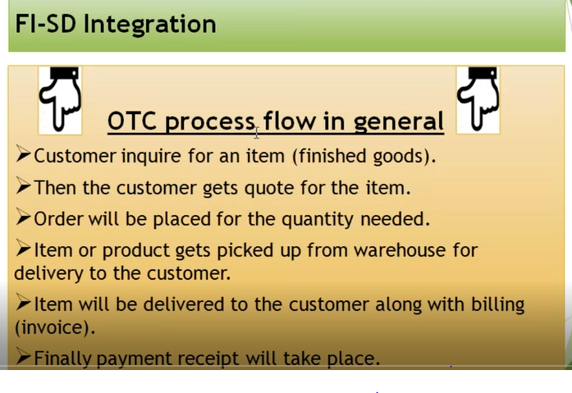

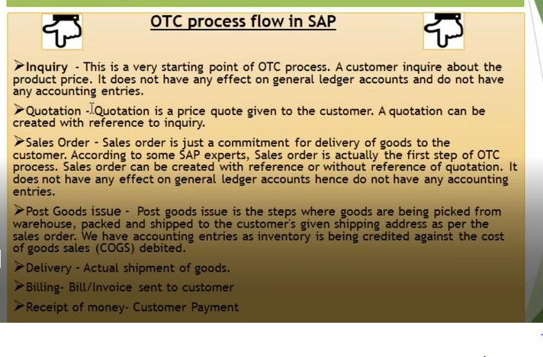

OTC start with inquiry customer will inquiry about the product and price details, the next step will be sending the quotation to customer quotation is price quote given to customer, After agreeing the contract sales order creation happen, sales order creation can be with reference quotation or without reference, sales order is just commitment to delivery goods, the followed step will be PGI( post goods issue) PGI is the step where goods are being picked from warehouse packed and shipped to the customer given shipping address, while doing PGI one accounting entry will generate ( COGS A/C DR to inventory A/C),

Delivery follows PGI deliver the goods to customer, After that billing coming to picture , we are going to send bill to the customer for the goods delivered, we have accounting entry here ( Customer A/C DR to Revenue A/c), when we receive the payment one more accounting entry will generate ( bank A/c DR to customer A/c)

**Lockbox:**  Lockboxs are special depository accounts set up at a bank to which customer remit their invoice payments. Lockboxs help in speedy deposit of funds and clearance of customer accounts

Banks daily than submit company’s an electronic file listing all deposits and invoices that are paid against. Company’s than upload these files in SAP and update their balance and clear customers i.e. A/R accounts.

https://blogs.sap.com/2020/09/15/lockbox-deep-dive-in-sap-s-4hana/

## **Lockbox File Formats**

SAP supports both US lockbox file formats – BAI & BAI2.Each bank has its own standard BAI and BAI2, hence configuration and testing needs to be done depending on bank file configuration.

**Day 1** When the bank receives a check from customer with remittance information its sends it in Lockbox file. Lockbox file when processed will generate below accounting posting

          Dr Bank Clearing account – incoming

     Cr Lockbox Clearing Account

          Dr Lock box clearing account

     Cr Customer account (customer sub ledger)

**Day 2** when the check is cleared in bank, it appears in EBS. EBS when processed produces below accounting entry

Dr Bank Main GL

          Cr Bank Clearing Account – incoming

**Lock box configuration**

* **Create house bank : FI12**
* **Define posting parameters : OBAY**

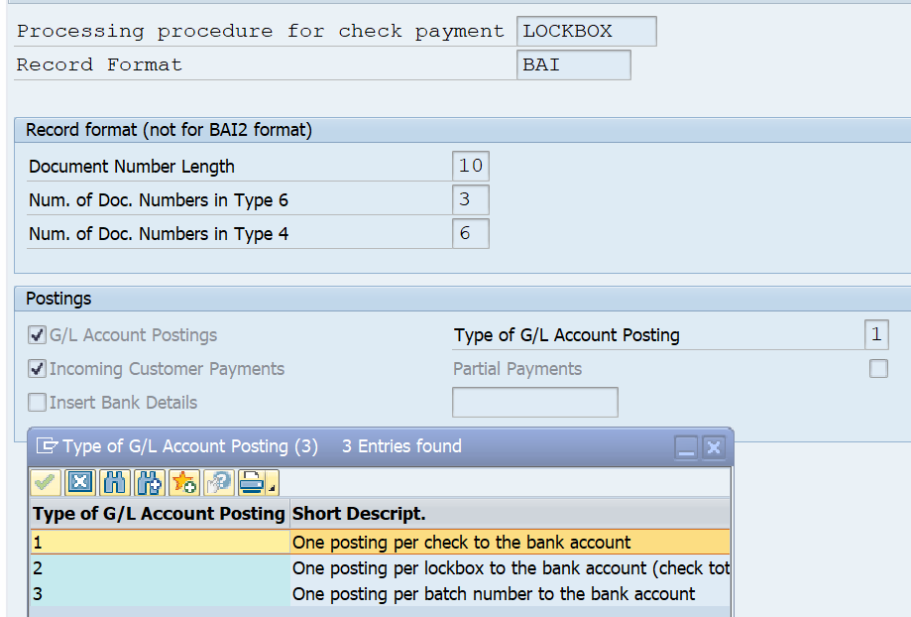

**Gl account postings: activate this indicator to make postings to your cash account in the GL for deposits.**

**Incoming customer payment: activate this indicator to make postings to AR subledger in order to clear the customer account and create residual postings.**

* **Posting data for Lockbox : OBAX**

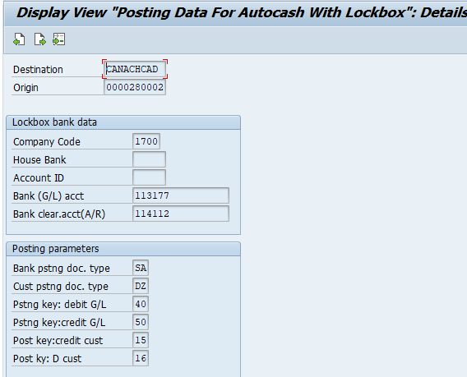

**Destination:** This field should contain the destination code the bank submits to you in your lockbox file

**Origin:** This field should contain the your lockbox number (bank account) number at the bank

Lockbox processing : FLb2 ( FLb1 manually clearing)

**Asset accounting**

|  |
| --- |
| **CONFIGURATION STEPS:ORFA** |
| o Copy reference chart of depreciation: EC08  Assign Charts of depreciation to company code: OAOB |
| o Assign input tax indicator for non-taxable acquisition: OBCL |
| o Specify Account Determination: |
| o Create Screen Layout Rules:AO21 |
| o Define Number Range Intervals: AS08  o Define Asset Classes: OAOA |
| o Create G/L Accounts:FS00 |
| o Assign G/L accounts: AO90 |
| o Determine Depreciation area in the Asset Class: OAYZ |
| o Specify Document Type for Posting of Depreciation: |
| o Specify Intervals and Posting Rules: OAYR |
| o Define Depreciation Methods:  o maintain Depreciation Key: AFAMA  o moving the balance for one year to next year : AJRW(execute it in back ground mode.)  Check the previous fiscal year: OAAQ    Asset post capitalization means, if we forgot to capitalized asset for the closed fiscal year, then we have procedure to capitalize those assets... that will be calling as post capitalization of Asset.    **Post Capitalization is for**  Post-capitalization represents subsequent corrections to the acquisition and production costs of a fixed asset. An example of when you need this type of correction is if you neglected to add expenditures and costs linked with the acquisition or assembly of an asset to its APC in a fiscal year that is now closed.   * **Chart of depreciation: COD is list of depreciation areas, Charts of depreciation are used in order to manage various legal requirements for the depreciation and valuation of assets.**   **(if company is operating all *company* codes in one country no need to assign multiple COD, if company operating multiple countries yes we can assign multiple COD.)(Charts of depreciation are used in order to manage various legal requirements for the depreciation and valuation of assets. The chart of deprecation is usually at a country level and assigned to a company code. It includes all the procedures for the assets assigned under that chart)**   * **Assign TAX CODE FOR NON TAXABLE TRANSACTION:** * **This indicator will use system whenever we will post acquisitions that are not subject to tax. but which are posted account that are tax relevant, we required to specify zero percent tax code for this.** * **Where ever acquisition or sales happened and there is no tax is involved in this case we have to use 0% tax.**   **EX: There is any acquisition happened in-house, for this tax is not involved foe this tax code need.**   * **Chart of depreciation: 1IN Is reference COD given by sap** * **Assign Charts of depreciation to company code** * **Specify account determination:** **The ACCOUNT DETERMINATION determine the reconciliation account in the GL, AD will links the asset class or asset mater records to the GL account, whatever the values posted in assets get automatically posted in GL.**   The **account determination** key defines the **accounts** in Financial Accounting that should be posted during asset transactions, for each chart of **accounts** and depreciation area (defined as an automatic posting area) in the chart of depreciation.   * **ASSET SCREEN LAYOUT:SL will control the fields in Asset master data** * **Define number range intervals:AS08** * **Asset classes: AC is group of similar assets.** **Each asset master record must be assigned to one asset class)(its similar nature of assets club in to group that group is called as Asset class)**   **Special asset classes are for example**  **1. Asset under construction**  **2. Low value asset**  **3. Leased assets**  **4. Financial asset**   * **AC is linked with account determination, screen layout as well as number range.**      * **Assign GL accounts to asset class:**   **We have to create our one ledger account and each asset ledger account will have respective Accumulated depreciation ledger account except land and asset under construction assets.**  **( Asset under construction will not have any depreciation ledger as the asset under construction are those which are construction stage they are not yet used in business so they will not be chargeable for the depreciation)**     **What is the difference between depreciation expense and accumulated depreciation?** ***Depreciation expense* is the amount of**[**depreciation**](https://www.accountingcoach.com/blog/what-is-depreciation)**that is reported on the**[**income statement**](https://www.accountingcoach.com/blog/what-is-the-income-statement)**. In other words, it is the amount that pertains only to the period of time indicated in the heading of the income statement.**  ***Accumulated depreciation* is the total amount of depreciation that has been taken on a company's assets up to the date of the**[**balance sheet**](https://www.accountingcoach.com/blog/balance-sheet)**. Accumulated depreciation is also the title of the**[**contra asset account**](https://www.accountingcoach.com/blog/contra-asset-account)**reported in the property, plant and equipment section of the balance sheet. The accumulated depreciation for an individual asset is subtracted from the asset's cost in determining the asset's carrying value or book value.**    **To illustrate, let's assume that we purchased one machinery at a cost of $84,000. This asset is estimated to have a useful life of 7 years (84 months), no salvage value, and will be depreciated using the straight-line depreciation method. Therefore, during each month of the asset's life the retailer will report depreciation expense of $1,000. However, the accumulated depreciation will be reported on the balance sheet at $1,000 after the first month, $2,000 after the second month, $3,000 after the third month, and so on until it reaches $84,000 at the end of 84 months.**   * **Depreciation are: each depreciation area permits use of all forms of depreciation, interest and revaluation calculation.( up to 99 depreciation areas can be created and used in system) Depreciation Areas. You use depreciation areas to calculate different values in parallel for each fixed asset for different purposes. ... Since the system allows you to define up to 99 depreciation areas, you can manage many different types of valuation (in Asset Accounting Customizing under Valuation ).**      * **Define document type for posting of depreciation: standard document type : AF** * **Specify intervals and posting rules: how we need to calculate the depreciation whether monthly or daily, in real time mostly companies will use period of depreciation will be monthly postings.** * **Determine depreciation area in asset class: screen lay out will be 1000 standard one** * **Depreciation calculation methods.**      * **Straight line method :( base method) 011 depreciation will calculate on acquisition value.** * **Declining balance method: depreciation will calculate on net book value.** * **Define multiple level method: this method will provide you the flexibility to provide different rates of depreciation for difference years**   **Ex: some cases deprecation rate is required deference in initial years after percentage will change**  **(Asset life is 10 years first 6 years it should charge 20% after 4 years it should charge 10% depreciation, by using this method it will automatically change the charge difference percentage)**  **Delta depreciation:** **When you have parallel dep areas, a delta area is always required to post the delta/differential values between the two dep areas.. So, in two, you will have 2+1 = 3 dep areas**  **You will add a delta dep area from the same IMG menu from where you are creating the IFRS dep area... Use the "wizard" option while creating dep area and you will get a step-by-step mandate from the system itself...**  **Diminishing Balance Method**  **Diminishing Balance Method, depreciation is charged at a fixed percentage on the book value of the asset. As the book value reduces every year, it is also known as the Reducing Balance Method or Written-down Value Method.**   * **Maintain depreciation Key: AFAMA**   **Depreciation key also known as a valuation key and it will control the valuation of asset in particular depreciation area,** We control the rate of depreciation and method of depreciation through depreciation key. **it contains the calculation method which is combination of below**  **1. Period of depreciation**  **2. Method of depreciation**  **3. Scarp value if any**  **4. Planned change in method of depreciation.**    **Period control**     * **Unit test testing:**     **Recalculate depreciation: AFAR**  **Asset under contractions**    **Assign allocation profile: OAAZ**  **Capital WIP( Work in progress ) is refer to as asset under construction in sap , depreciation will not charge to WIP asset , the cost incurred on the WIP asset can be booked to internal order and through the settlement process can be posted in to asset under construction.**      **Settlement rules :Before settling the AUC asset to final asset distribution rule must assign to asset master record,**  **The transfer from AUC to final fixed asset held in two ways one is summery transfer from normal asset to receiver asset and another one is line item settlements,**  **with line item settlement or without**  **Settlement rule for AUC asset: AIAB**  **Step-1**    **Step-2**    **Step-3**    **Step-4: once we move back the selected line item for settlement rule turn red to green, means distribution rule has been created.**    **Allocation profile: OAAZ**    **AUC settlement: AIBU**    **Peivew: how Auc line item is settling**    **Now execute**    **Asset line items has been transferred**    **AUC settlement with internal order**              **IO to AUC settlement process steps**  **Before creating internal order**  1) Create asset class(AUC) and click on radio button Investment measure  2) Give Balance sheet account in Ao90 and finish the configurations in AFAMS,AFAMP and OAYZ  3) Maintain Allocation structures(OKO6) and cost elements primary or secondary  4) maintain Settlement profile(OKO7) and make G/L,Cost center,order,WBS,FA etc. as optional  **We need to assign the allocation structure and object type as well as valid receiver here**    5)In KOT2_OPA create order type.Here,need to give settlement profile,planning profile 000001(general),Budget profile-0000C1(general),Object class-Investment, staus profile-00000002(IO) and check Release immediately radio button.  6) Create Investment profile(OITA).Give here investment measure asset class as which we created in step 1.Under settlement,we need to select summary settlement and save  **After creating internal order**  1. first create an internal order through KO01. That internal order type should be for investment purpose.  2. Give the relevant detials and go to investment tab and give investment profile.  3 Then in toolbar go to extras and select "asset under construction". An asset under construction would be created and give the details of this asset.  4. Then release the internal order in KO02.  5. Then go to FB60 and post a invoice with this internal order as account assignment object.  6. GO to KO02 and in extras see the order balance. that amount would be reflected in the order.  7. now go to KO88 and execute the internal order through which your internal order will be credited and AUC which you created would be debited.  8. Now go to KO02 and see the order balance it would show 0 as it is moved to AUC.  9. Now to go to settement rule and give the asset to which u want to transfer this amount and take the category as FXA and give the detials.  9. now go to KO02 and change the status of internal order to "TECO complete".  10 Now go to KO88 and execute the order and now the AUC is credited and your asset is debited.  This is the exhaustive steps which i think wil solve your purpose.  But make sure the configuration about the order type and investment profile are properly maintained  **More configurations in AA..**   * **Define depreciation areas for special depreciation.** * **Define the cut-off value key.** * **Define/assign settlement profile. (AUC configurations) AI**     **HOW DEPRECIATION AREA POST TO GENERAl LEDGER IN REAL TIME OUT OF TWO OR FOUR:** |
|  |
|  |
|  |
| **Asset accounting entries** |
| **purchase of asset**  Asset A/C (70) Dr  To vendor (31) Cr  **Sales of asset**  Customer A/C (01) Dr  Asset Sale A/C (50) Cr  Acc. Dep. on Asset (70) Dr  Profit on Asset sale (50) Cr or Loss on Asset sale (40) Dr  **Deprecation posting**  Depreciation A/C Dr  To Acc. Dep A/C Cr  **scraping of asset** |

For example asset value is 12000 and 12 months useful life and after completing useful life asset is scarped with 2000 and sold to customer entry will be

If we don’t have loss made on asset scrapping account( balance sheet , debit what comes in credit what goes out)

|  |  |  |
| --- | --- | --- |
| Account | Debit | Credit |
| Customer | 1000 |  |
| ACC Dep | 12000 |  |
| Asset APC |  | 12000 |
| Gain on sale |  | 1000 |

IF we scrap asset with loss entry should be . Lets breakdown step by step ;

APC value : 12000

ACC dep : 10000

Net book value is : 2000

Scrap sale: 1000

Customer pay : 1000

|  |  |  |
| --- | --- | --- |
| Account | Debit | Credit |
| Customer | 1000 |  |
| ACC dep | 10000 |  |
| Loss on asset | 1000 |  |
| APC account |  | 12000 |
|  |  |  |

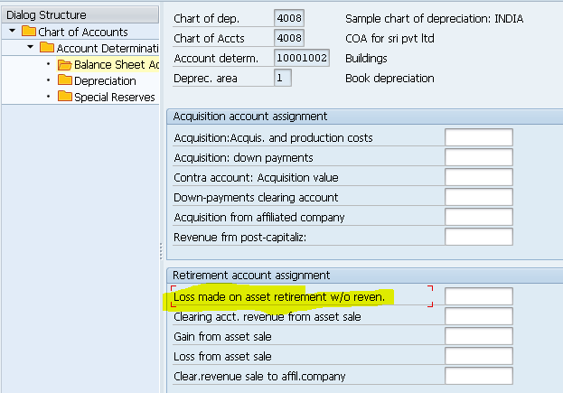

**Technical clearing account entries**

* **At the time of GR : if gr non valuated option is unchecked ( operational part)**

**Technical clearing A/C DR**

**To GR/IR account**

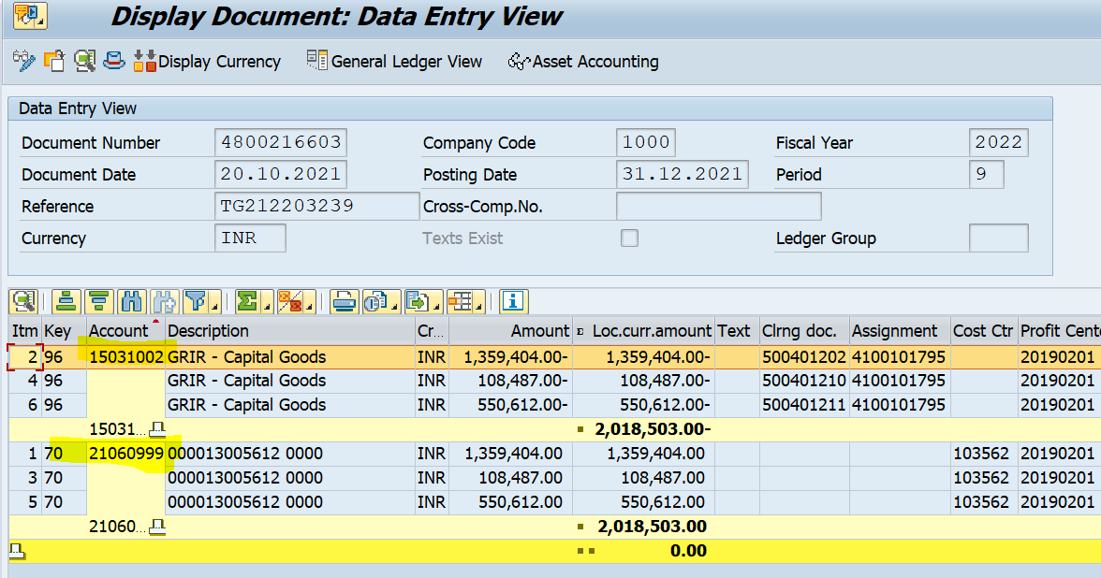

* **When asset is capitalized (valuation part)**

**Asset account DR**

**To technical clearing account**

**GR valuation example: System create the accounting entry and asset value posted at the time of goods receipt. Ex: machinery / vehicle purchased and ready for use upon delivery.**

**GR non-valuated: No document entry at the time of GR. Asset value posted at the time of invoice.**

**EX: Asset procurement where total cost include service and additional changes confirmed only at the time of invoice.**

## **Main Tables**

COBRA : Settlement Rule for Order Settlement  
COBRB : Settlement Rules (especially ERSJA, ERSPE, LETJA, LETPE)  
AUAK   : Settlement documents  
              - AUAK Settlement document header  
              - AUAV Settlement transactions  
              - AUAA  Sender and receivers  
              - AUAS   Settled costs

COSS, COSP, COSL, COSB : costs posted to the object  
COEP : Lines items posted to the object  
COSSD, COSPD, COSLD, COSBD : Settled Amount  
JEST, JCDS : System status and change documents

**Link : https://wiki.scn.sap.com/wiki/display/ERPFI/Internal+Order+Settlement**

**Tax on sales and purchase**

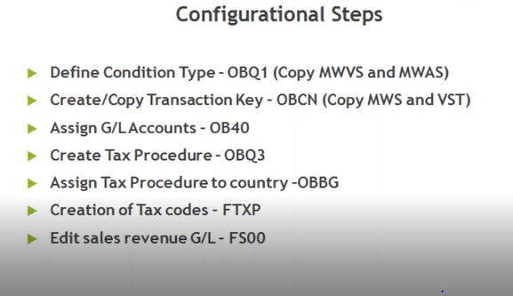

* **Initially we have to define the condition type based on standard SAP condition type: OBQ1**

**1. MWVS: INPUT TAX**

**2. MWAS: OUT PUT TAX**

**Like how tax should calculate like percentage or fixed we should maintain based on control data**

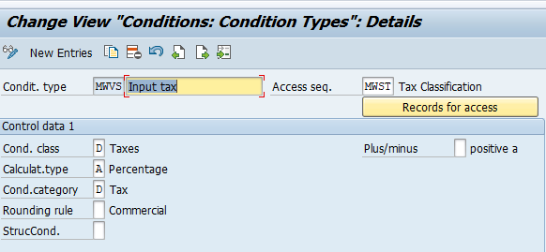

* **Create traction key for the purpose of assign gl accounts: OBCN**

**1. VST: INPUT TAX**

**2. MWS: OUTPUT**

**What is the tax type and posting indicator**

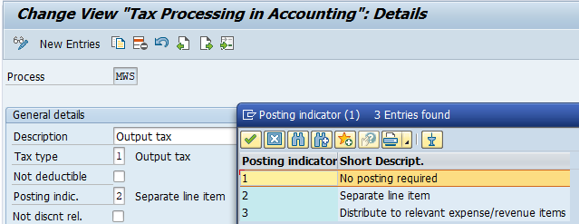

* **Assign gl accounts to traction key : OB40**
* **Create TAX procedure : OBQ3**

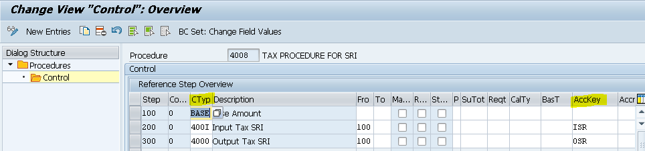

* **Assign tax procedure to country :OBBG**
* **Creation tax code : FTXP**

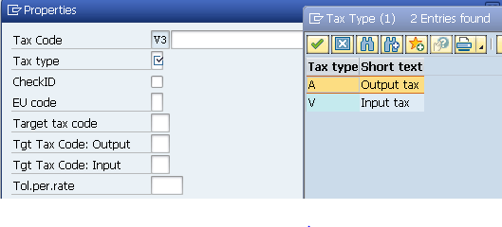

* **Check calculation procedure: OBYZ**

**Target tax code:**

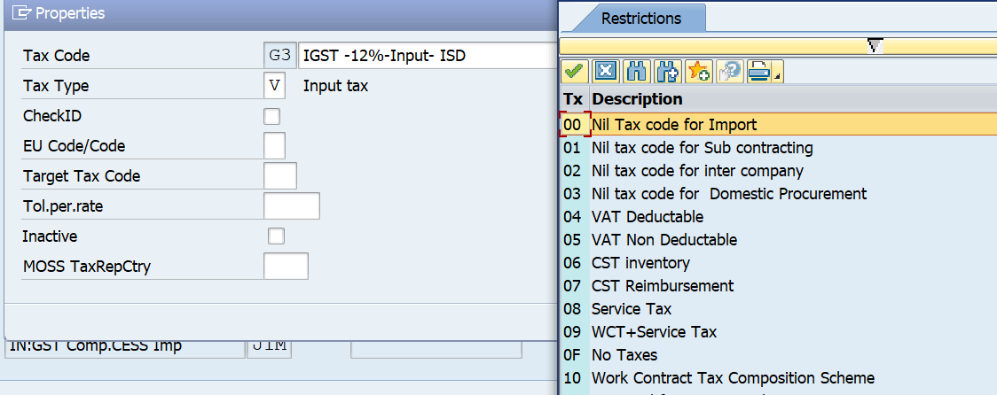

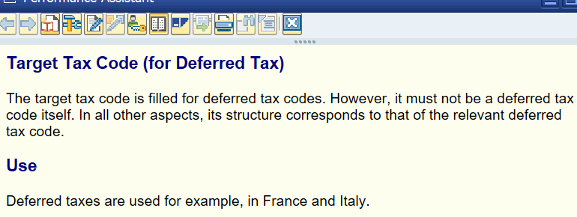

**What is differed tax : Differed tax referred tax that is accounted but not paid / received immediately.**

**Foreign currency settings**

* **Foreign currency settings**

**Check exchange rate type: OB07**

**1. Define translation ration for currency translation: OBBS**

**2. Enter exchange rate (maintain exchange rate table): OB08**

**Exchange rate differences: OBA1 (monthly activity)**

* **See all configuration details: oby6**
* **For maintaining the exchange rage type TABLE LEVEL : TCURR(TABLE NAME)**
* **Bank Buying Rate (G Type) : – This rate type is used for when the bank is buying from Company. For E.g. Exports.**
* **Bank Selling Rate (B Type) : – This rate is used for when the bank is selling to company. For e.g. Imports.**
* **Average Type (M Type) : – This is average exchange rate.**
* **(When clearing open items in a foreign currency, exchange rate differences may occur due to fluctuations in exchange rates. The system posts these exchange rate differences automatically as realized gains or losses. The realized difference is stored in the cleared line item.**
* **Exchange rate differences are also posted when open items are valuated for the financial statements. These exchange rate differences from valuation are posted to another exchange rate difference account and to a financial statement adjustment account. When clearing an open item that has already been valuated, the system reverses the balance sheet correction account and posts the remaining exchange rate difference to the account for realized exchange rate differences.)**
* **Direct quotation :**

**One unit of foreign currency shows the total value of local currency**

* **Indirect quotation :**

**One unit of local currency shows the total value of foreign currency**

**Direct quotation is where the cost one unit of foreign currency is given in units of local currency, whereas indirect quotation is where the cost of one unit of local currency is given in units of foreign currency**

# **KDF and KDB in OBA1 _ Foreign currency valuation**

**I would like to confirm my understanding about OBA1 -> KDB.**

**1) KDB is used for non open item managed GL accounts.**

**in KDB we can create a exchange rate difference key and we will have to mention this key in the master data of each GL account to be valuated at the period end.**

**2) KDF will have bank sub accounts and all the accounts which are managed open item basis and to be captured in the evaluation**

**Foreign currency valuation: F.05( if new gl:** **FAGL_FCV)**

**Valuation area:** By defining your valuation areas, you can report different valuation approaches and post to different accounts. In this IMG activity, you define your valuation areas for your closing operations. The valuation method we defined above will be assigned to our valuation area we will define in this step

**Valuation method:** The valuation method basically contains the relevant parameters in the valuation process. In this step we make all the specifications necessary for the SAP valuation program to run.

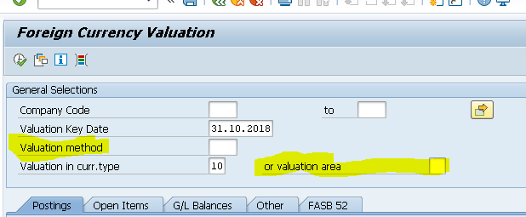

**Valuation area and valuation method details**

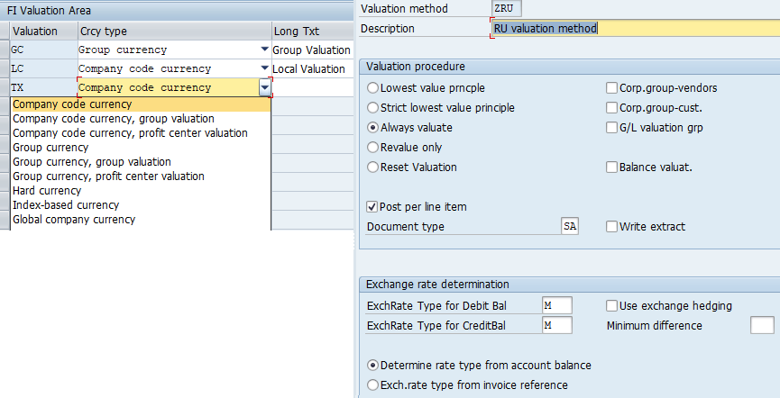

**OB22:**

**Valuation:**

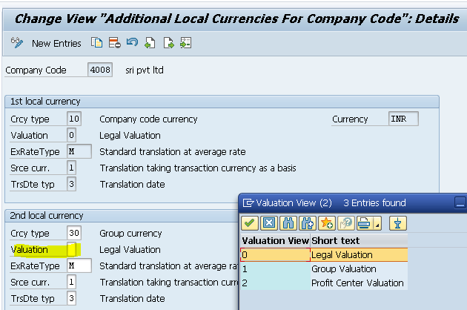

**Translation date:**

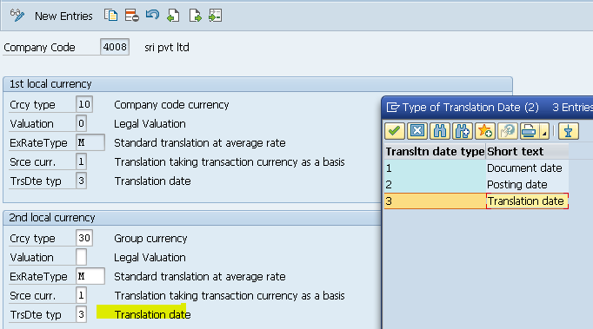

The type of the translation date determines which date should be used for the translation of the amounts according to the exchange rate tables

**I will mention entries from Vendor point of view on that basis you can get the idea.**

**1. If there is a Unrealised loss.**

**Unrealised loss A/c...............Dr.**

**To Balance Sheet Readjustment A/c......Cr.**

**2. If there is a Unrealised Gain.**

**Balance Sheet Readjustment A/c......Dr.**

**To Unrealised Gain A/c.....................Cr.**

**3. If there is a Realised Loss.**

**Realised Loss A/c......Dr.**

**Vendor A/c.................Dr.**

**To Bank A/c.......................Cr.**

**4.If there is a Realised Gain.**

**Vendor A/c..........Dr.**

**To Bank A/c....................Cr.**

**To Realised Gain A/c.......Cr.**

**S/4 screen FAGL_FCV**

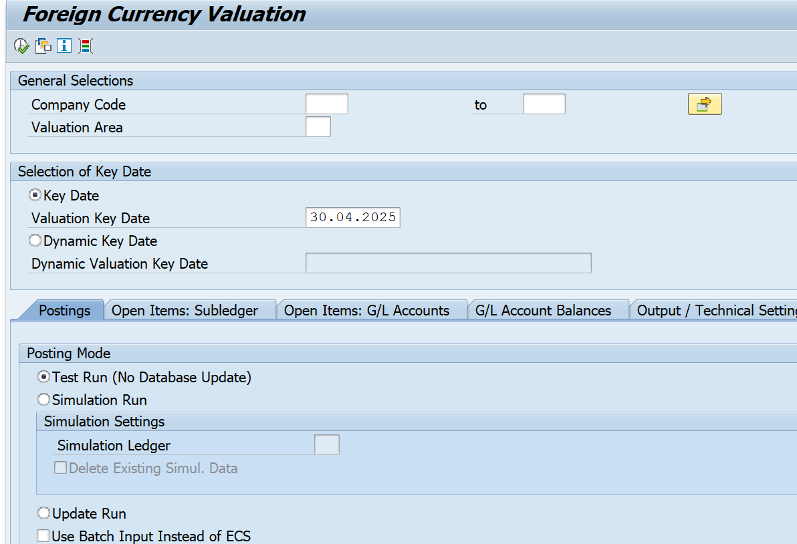

**ECC screen F.05**

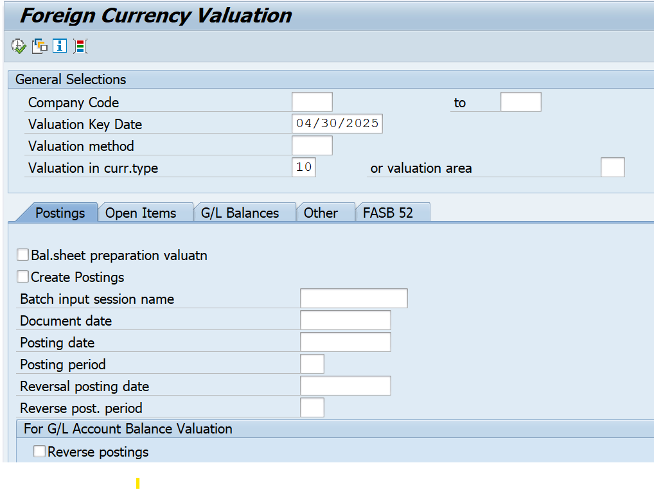

**Substitution**

Substitution rule will substitute wrong value to right value.

* **Define substitution rule: ggb1**
* **Activate the substitution: OBBH**

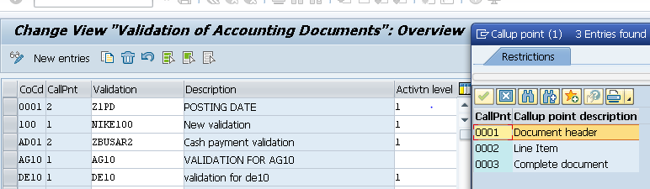

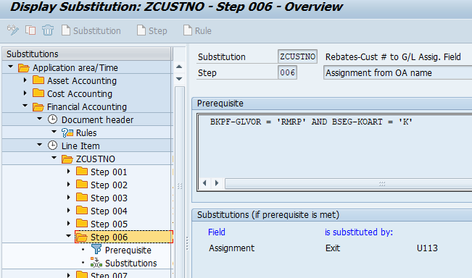

**In s/4 we have new call point**

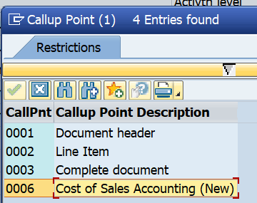

**Validation**

**Validation is rule define by the functional consultant, it will validate two or more than two page as given criteria.**

* **Define validation rule: GGB0**
* **Activate the validation :** **OB28**
* **Check the technical name: SE11**

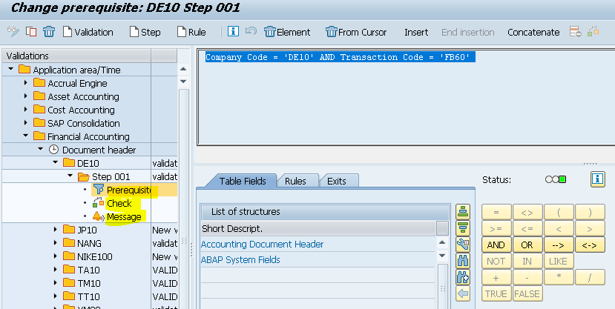

Prerequisite: prerequisite is going to specify the validation criteria. prerequisite specify under with condition validation is going to work out.

Check: for writing the validation rule we can use check, check here we are going to specify validation rule

**Example: whenever user is changing the payment terms in FB02 one information message should popup and enter the details for changing payment terms in text**

**Prerequisite :** BKPF-TCODE <> 'FB02' AND Document type <RE,KR>

**Check : Payment terms change**

**Message: please specify the reason for payment term change**

NEW GL

Before new gl we were using classic gl in classic gl we don’t have the few functionality.

**PARALLEL ACCOUNTING BY NON-LEADING LEDGER**

**Types of ledgers**

* **Leading ledger**
* **NON-Leading ledger**

**Leading ledger: In the leading ledger all the postings will take primarily and default, leading ledger in sap defined as 0L and company codes are assigned to this ledger by default.**

**NON-Leading ledger: The non-leading ledgers are parallel ledgers to leading ledger, It can be based on a local accounting principles, Non leading ledger can have different fiscal year variant and difference posting period variant.**

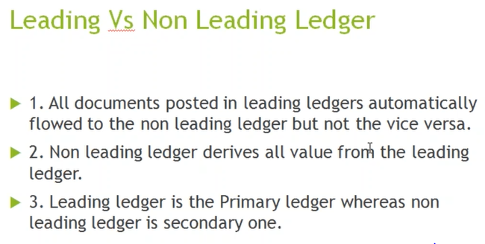

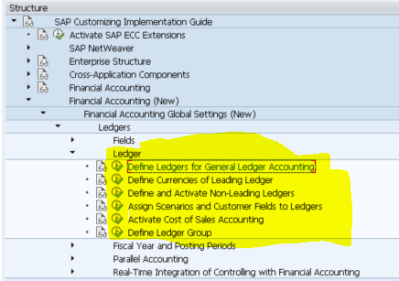

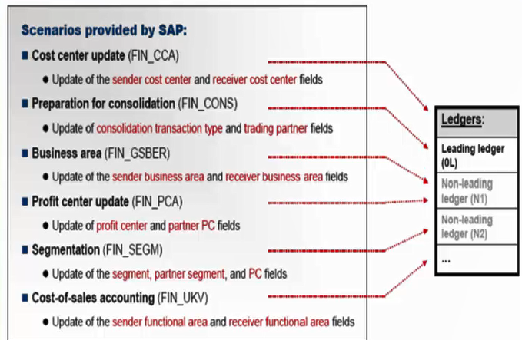

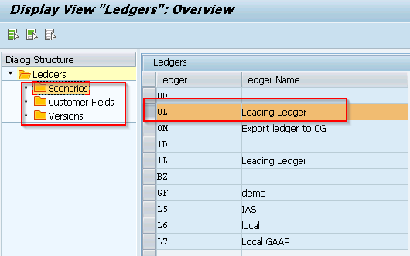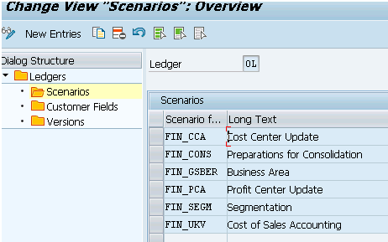

**USE :** You assign the desired scenarios to your ledgers. For each ledger, you define which fields are filled with posting data from other application components.

**Parallel reporting:**

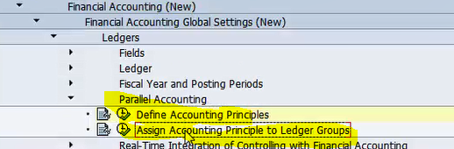

* **Every organisation has to prepare there financial reports according to the accounting standards, preparing financial report for a company which follow one accounting principle it is easy to compared with others,**
* **But in case of organisation required by to submit financial reports in different account standards this become little difficult.**
* **And this is where the parallel accounting come into picture to help you to achieve your target without maintaining the multiple sheets.**
* **The system usually uses the representative ledger of the ledger group to find the fiscal year variant and the current company code. The system checks whether the posting period is open for the specified company code. If the posting period is open, the system posts to all assigned ledgers of the ledger group using the appropriate fiscal year variant for each individual ledger. The system posts to all other assigned ledgers, even if their posting periods are closed.**

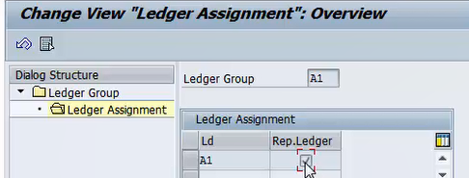

**If you want the system to determine and check the fiscal year variant and the posting periods of the non-representative ledgers independently of the representative ledger, set the Manage Posting Period indicator in Customizing for Financial Accounting (New) under Financial Accounting Global Settings (New) ® Global Parameters for Company Code ® Enter Global Parameters. In addition, define the differing posting periods and the differing fi scal year variants for the relevant ledgers under Financial Accounting Global Settings (New) ® Ledgers ® Ledger ® Define and Activate Non-Leading Ledgers. The system only makes the posting in this case if the posting period is open for all ledgers of the ledger group.**

**Ex:** Nike headquarter at USA has subsidiaries in India (company code 1200) and Australia (company code 1100).

Both company code is required to generate financial reports using different accounting principle and in various currencies.

Nike India is required to prepare financials

* For group reporting using US GAAP in INR, USD --- Fiscal year 1st OCT to 31st SEP
* For local authority using local GAAP in INR --------Fiscal year 1ST APR to 31st MAR
* For global reporting in IFRS in INR, USD ----------Fiscal year 1ST APR to 31st MAR

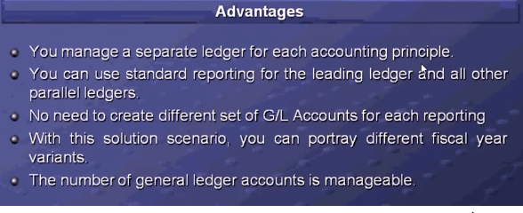

**DOCUMENT SPLITTING**

**With this document splitting accounting line items are split according to the specific characteristics. Document splitting, we are using for segment wise reporting purpose.** **Document splitting enables you allow draw financial statements for dimensions like profit center, business area, segments any time.**

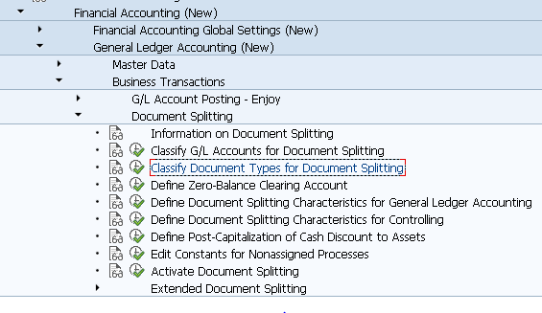

**Passive splitting: Passive splitting use for clearing the transactions, This type of splitting is mostly occurs when the payment transaction is posted for a vendor invoice**

Profit Center Level vendor Amount has been already split, so Bank Amount (Payment) will also split as same pre-defined criteria used for Vendor Invoicing

|  |  |  |  |
| --- | --- | --- | --- |
| **GL Account** | **Dr** | **Cr** | **Profit Center** |
| **Vendor Amount** | 8800 |  | PC 1 |
| **Vendor Amount** | 2200 |  | PC 2 |
| **Bank** |  | 8800 | PC 1 |
| **Bank** |  | 2200 | PC 2 |

Now the clearing transaction is also balanced on profit Center level.

**When we make vendor payment this payment always clears the vendor invoice which already outstanding in the vendor account, it clears the invoice against payments. We cannot change the settings for passive splitting.**

**Active Splitting:** **In Active Splitting the document is split according to my SAP ERP predefined rules.**

**Zero Balancing Splitting:** Zero balancing is taking care of document should be balanced also it should be balanced for specific characteristics (e.g. Profit Center)

**The system create clearing line automatically to achieve the splits, it ensures the not only the document balance is zero for the characteristic as well.**

**When the amounts within financial documents are not able to balance out to Debit of Profit Centre and Credit of Profit Centre which does not Net Off as its own, SAP then automatically generates new line item to balance the document.**

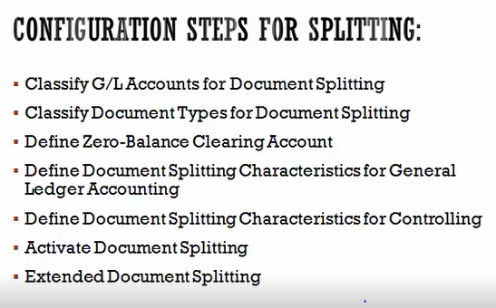

* **Item Category – Item category categorizes the general ledger accounts for document splitting. In the configuration each GL account is assigned to item category. Just to name a few like 01000 – Balance Sheet Account, 02000 – Customer, 03000 – Vendor and so on**.

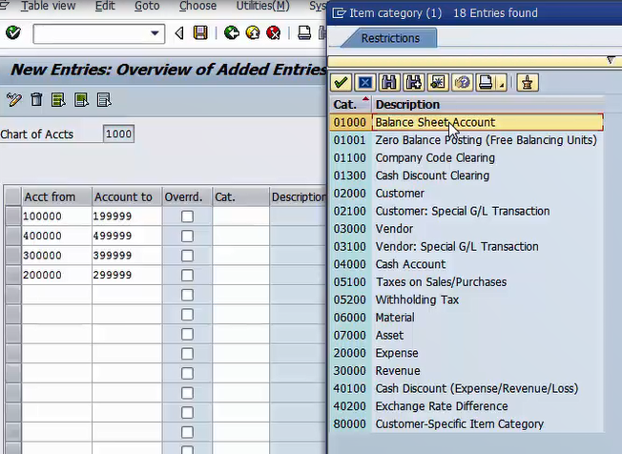

* **Business Transaction –** **Business transaction is real scenario of business processes happens in o rganization such as vendor invoice, customer invoice etc.**

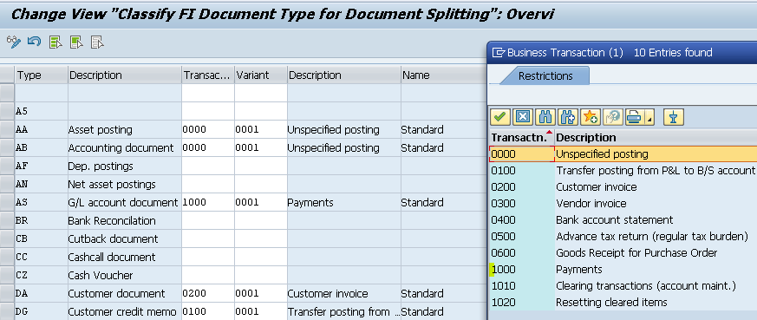

* **Business Transaction Variant – In the SAP, financial postings are derives the item category for individual line item. Business transaction variant always works in conjunction with business transaction where business transaction restricts the business processes to be posted to. System validates a check all postings against the item category to validate if these postings are allowed by splitting rule if not then understand this failed.**
* **Document splitting characteristics for gl account.: it will be done on client level**

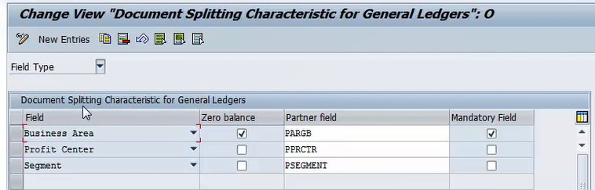

* **Extended document splitting: If standard document splitting not met the business requirement we can use this extended splitting and we can create our own methods and rules.**
* **Document Splitting Method – Document splitting method works in combination with business transaction and business transaction variant it determines the document splitting rule.**
* **Document Splitting Rule:** **Document splitting rule determines which item categories will be split and from which item categories it will derive the account assignment.**

**Entry view and GL view is possible in new GL**

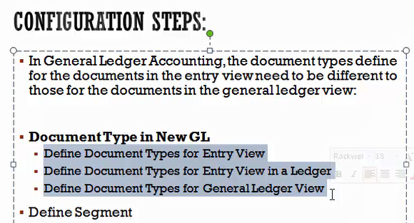

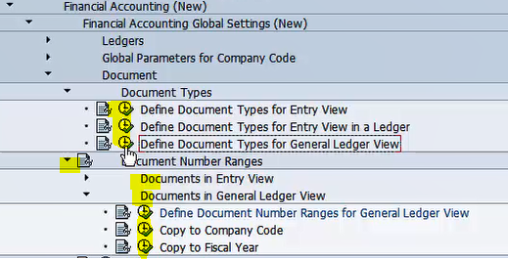

* **Define doc type for GL View: Generally this config use leading and non-leading ledger have got different fiscal year, we need to define doc type for non-leading ledger so this leger will post to different fiscal year.**

**EBS (OT83)**

**Introduction**

Medium to large scale businesses do thousands of transactions each day. Lot of these transactions are banking related. Reconciling bank balances with book balances manually is not possible.

Uploading manual bank statement in ERP system is a time consuming and errors will come due to manual intervention. Treasury staff in an organisation may end up spending lot of time usually at the end of month for reconciliation.

Electronic bank statement feature provided by SAP can save a lot of time and is error free. IN SAP we will upload the file which is sent (FTP) by bank. Based upon SAP configurations financial postings will be done. This configuration will upload the statement automatically and at the same time will do the bank sub ledger postings and clearing postings.

**SAP Configuration of electronic bank statement (EBS)**

Financial Accounting –> Bank Accounting –> Business Transaction –> Payment Transactions –> Electronic bank statement

EBS is done at Chart of Account Level

1. Account symbol creation – Account symbols are specifications for general ledger accounts. These are posted with each possible transaction contained in bank statement.

2. Assign accounts to account symbol – GL accounts are mapped to account symbols in this step.

3. Create keys for posting rule – Description for the necessary posting rules is entered in this step. Each posting rule represents a business transaction.

4. Define posting rules – In this activity posting specifications for each posting rule is created. You specify how a certain business transaction is to be posted with which posting key, document type and posting type.

5. Create transaction type – Transaction type contains the external transaction type. External transaction types are codes used by banks to specify the business transaction sin bank file. Transaction types in turn  are link between External Transaction Types, Posting Rules and Interpretation Algorithms. interprets the note to payee line in bank statement and accordingly clears the open items accordingly.

6. Assign bank account to transaction types – Last step involved is assigning bank accounts with transaction types as defined above. This step contains the list of external transaction which are valid for a house bank. Please note that assignment is of Bank account number and Bank Routing Number and not of GL account in this step.

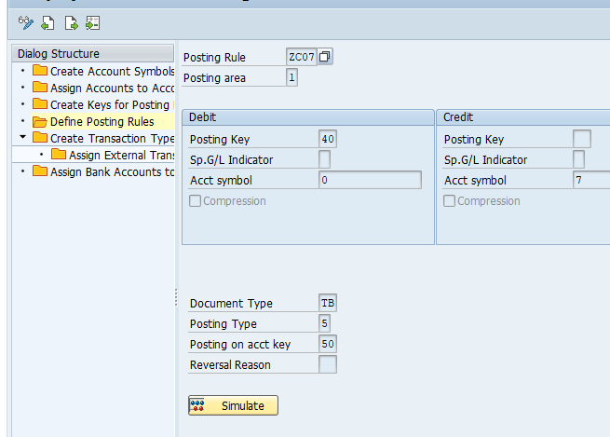

**File format**

There are many EBS file format currently being used. Most commonly used are BAI, MT940 and Multi Cash formats.

BAI format is a standard format and recommended by SAP. Main difference between BAI and other formats is that it allows file to be processed even if some of the external transaction codes are not available in SAP. System will post all those transactions which have valid external transaction codes. Missing codes need to be mapped and the statement need to be reprocessed using standard SAP transaction code FEBAN (Edit bank statement).

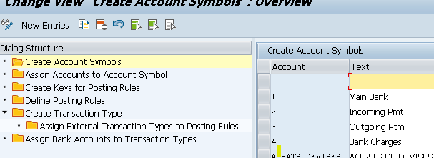

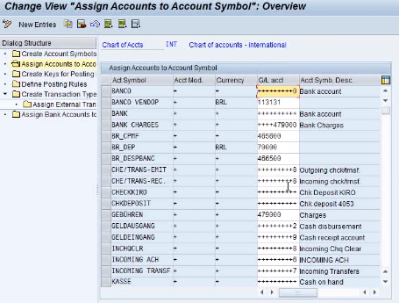

* **To upload the bank statement : FF_5**
* **Creation of house bank: Fi01**
* **Creation of house bank with sub account : Fi12**

**File format: BAI2**

**BAI2 file is a plain text file (.TXT Format), The file records with 01, 02 and 03 contain the basic information with regards to Bank Routing No (Bank Key). File generation date, Statement date, Bank Account no., Opening Balance, etc,**

**The file records with 88 always contain some extra information about the preceding record. In the above screenshot, the records with 88 after the 03 record, contain information about Closing Balance, Total Debits and Total Credits**

**The file records beginning with 16 contain the transactional information – Checks In / Out, Wires In / Out, Bank Charges, Bank Interest, etc. Each one of these transactions is represented by a unique transaction type. For example, 475 for Checks Out, 354 for Interest Income, etc. We use these transactions to trigger the various postings in the FI – General Ledger**

**Flow:**

* **First system is going to identify the bank account number, against this bank account number which transition type we have linked it will identify. Bank codes we are defining in external transaction type.**
* **Under Transaction type what are the posting rules we have assigned, Accounting entry will take placed based on the posting rules,**
* **As per the posting rule what should be the accounting entry it will identify, here we have defining entries based on the accounting symbols**
* **In assign account to account symbol field we can assign the gl account for account symbol**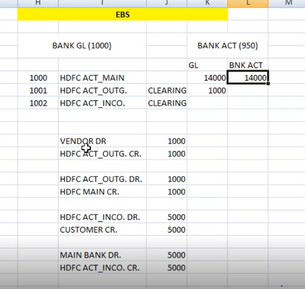

**FI01: we will create bank master data ( house bank, vendor , customer) and it will store in BNKA table, below are the fields we can create in bank master data.**

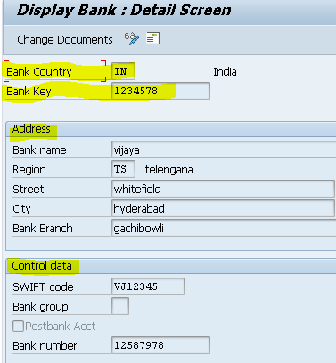

**Fi12:** **But in fi12 you create House bank and Bank id and also assign Bank GL also**

**But Fi01 is only the Bank key that means SAP identifies the bank a/c as a bank key**

**Without house bank not possible to create bank id, Data will store in T012, T012K**

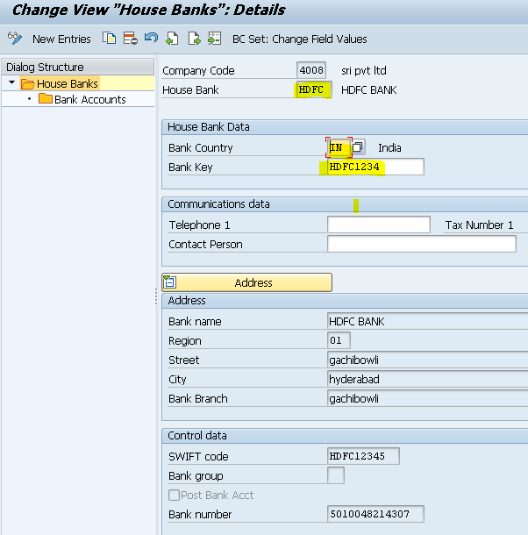

**As far is my knowledge, House Bank creation (FI12) is for the bank which you are creating for your company and company code.**

**FI01 is for creation of vendor and customer bank accounts, which is no relevance to assign it to our house bank. But the fields are same.**

**Note: You can create your company code house banks in FI01 also, but then later you need to extend that in FI12 to assign other details like bank clearing account and etc....**

**More details:**

MT940 file format will use Europe region

BAI format will use in US

MT940 only format use in INDIA

**MT940 file Format**

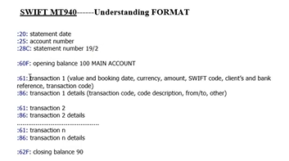

* **61 code will provide the details about transaction**
* **86 code will provide the additional details about transaction (if 61 is for bank changes , in 86 will provide additional details like for what transaction charges or check bounce this is called note to payee).**

**Where as in BAI 16 is transaction details and 88 is additional details.**

**When you are uploading the statement how system will clear the outgoing / incoming payment sub accounts**

* When ever we are sending the file to bank we will mention the additional details on the file like reference number or document number
* When we received the bank statement there also bank will mention reference or document number details.
* And based on interpretation algorithm which we maintained in external transaction type settings, system will go and check the details in REGUP table and clear the documents.

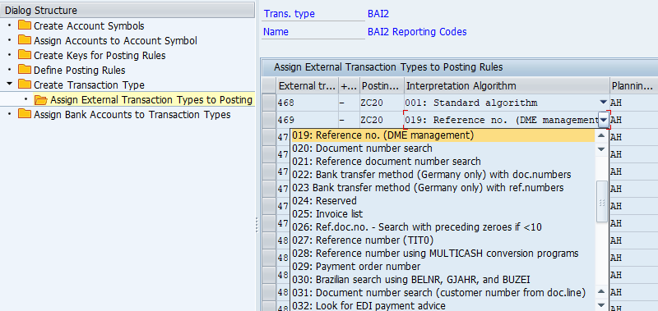

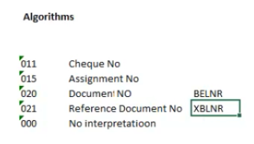

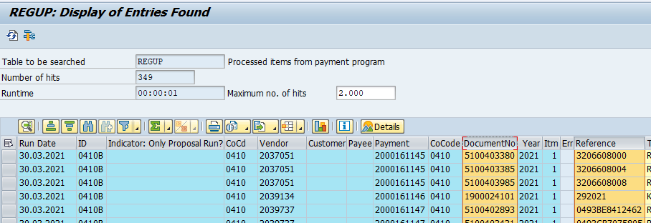

* If it is customer we will give the VF01 billing document to customer, in that we have reference number.
* If it is incoming payment customer will mention the details about payment in check or transfer like reference number.

Based on interpretation algorithm we can find the customer or vendor documents only but clearing is possible only with posting rules,

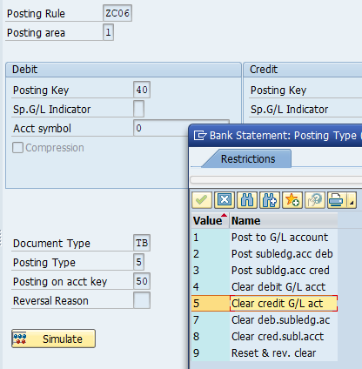

**Search string:** if business want pass any data while uploading the statement like if bank charges on forex name is there it has to hit to so and so cost center like that it can be done based on search string.

Search string only applicable for 86(mt940- note to payee) or 88(bai) fields,

Simulation of search string like how many strings are working on house bank after uploading statement only: FEBSTS

After uploading statement if any entries are not posting user will check in FEBAN and take action accordingly

**LSMW**

**LSMW is a tool that supports the transfer of data from non-SAP systems ("Legacy Systems") to SAP  R/3 systems it is used for mass data upload as well. This can be a one-time transfer as well as a periodic one.**

**LSMW can be used for all the master data and transaction data.**

**LSMW also supports conversion of data of the legacy system in a numerous way. The data can then be imported into the SAP R/3 system via batch input, direct input, BAPIs or IDocs.**

**LSMW can be used for following 3 functions -**

**The main functions of the LSM Workbench are:**

1. **Import data (legacy data in spreadsheet tables and/or sequential files)**
2. **Convert data (from source format to target format)**
3. **Import data (into the database of the R/3 application)**

**To start the LSMW workbench use transaction LSMW**

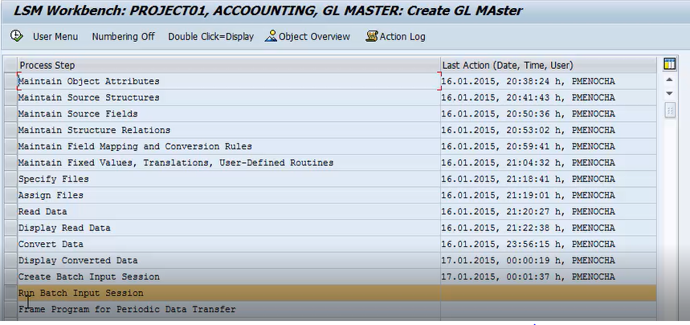

**1. maintain object attributes: which object type we are using for import the data whether batch input recording or others**

**2. Maintain source structure: The source structures can be used to design the hierarchy of the files to be uploaded.**

**3. maintain source fields: in this screen, the Fields which will be uploaded from the text file can be maintained here. The fields with identical names are taken as the Key**

**4. maintain source relations: The Structures which are needed for the processing of the data need to be assigned here. The Object may contain many structures and many source structures. The Mapping between the source and the target structures should be done after careful checking.**

**5. maintaining the field map and cover rules:** **In this 0step, you assign source fields to target fields and define how the field contents will be converted.**

**How data should transfer whether it is one time activity or periodic( once upload the gl account again after we want to upload few more gl)**

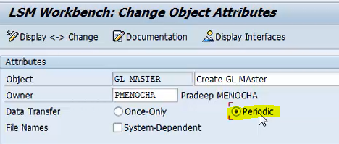

**How to extract one system to another system: WSR**

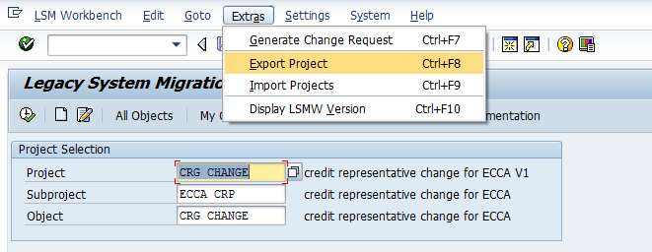

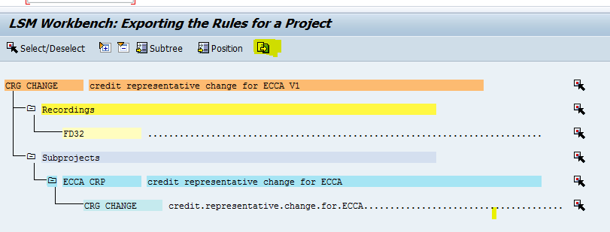

**TRAGET SYSTEM: WQR**

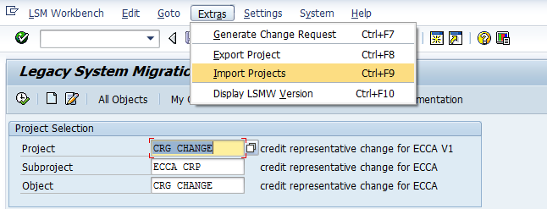

**LTMC**

1. Create object
2. Download Template.
3. Upload file.
4. Activate
5. Transfer
6. Validate Values
7. Convert Values
8. Simulate Values
9. Finish

**Financial statement version:**

**FSV is reporting tool, it can be used to extract final accounts from sap like P&L account and balance sheet : f.01**

**Created financial statement version nods or structure : OB58 we have to create nodes like how financial statement will look.**

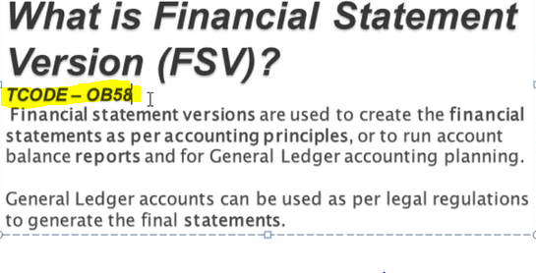

**Cash journal**

* Setup cash journal account:FBCJC0
* Number range for cash journals: FBCJC1
* Setup cash journal tranction:FBCJC2
* Cash journal posting: FBCJ

**\*cash journal is nothing but petty cash related transactions**

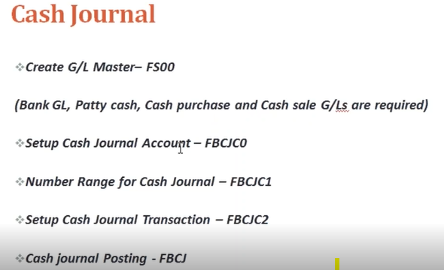

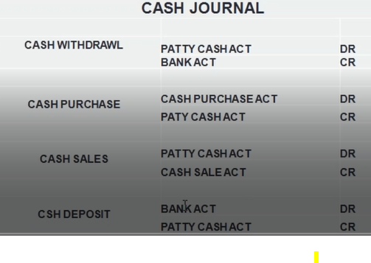

* **Setup cash journal account**

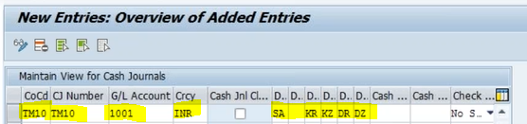

* **Number range for cash journal**
* **Setup cash journal transaction**

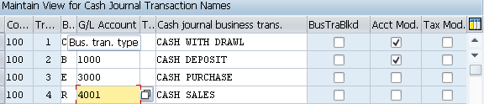

* **Cash journals postings**

**When we have two bank accounts hdfc and icici if we maintained hdfc is our cash receipts account if we want withdraw from icici account how can we do,**

**In setup cash journal transaction configuration flag the account modifier field for bank account.( gl account will become non editable mode to editable mode)**

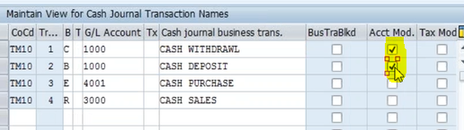

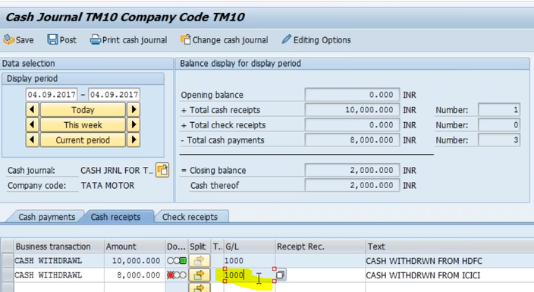

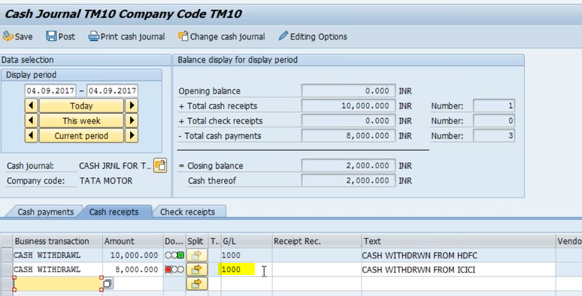

**Idoc**

**The purpose of an  IDoc(**I**ntermediate**Doc**ument) is to transfer data or information from SAP to other systems and vice versa.  The transfer from SAP to non-SAP system is done via EDI (Electronic Data Interchange) subsystems whereas for transfer between two SAP systems, ALE (application link enabling) is used.**

**IDoc can be triggered in SAP system or in EDI subsystem. This depends on the direction in which IDoc is sent and is called as Inbound IDoc and Outbound IDoc accordingly. In case of outbound flow, IDoc is triggered in SAP through document message control which is then sent to EDI subsystem. EDI converts the data from IDoc into XML or equivalent format and then sends the data to partner system through Internet.**

**For inbound flow, EDI converts partner data and IDoc is created in SAP. After successful processing of this IDoc, Application Document is posted in SAP.**

**Incase of outbond we have to maintain the receiver port and incase of inbound we have to maintain process code**

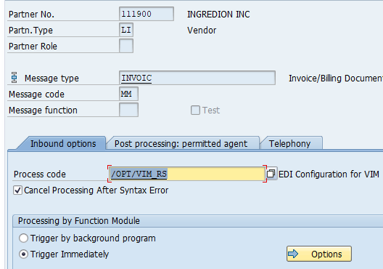

[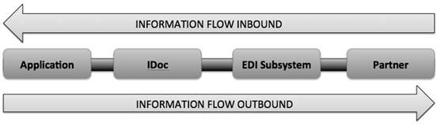](https://blogs.sap.com/wp-content/uploads/2012/12/1_170630.png)

**IDoc Port contains the information about the way data is sent between the source or target system. The type of port defines the information contained within the port. For port type “Internet” Port will contain IP address of the target system. For port type “file”, directory or file name information is maintained. “tRFC” port contains information about the RFC destination of the target system. For IDoc transmission using ALE “tRFC” ports are used.**

# TESTING AND EDITING IDOCS

**If an IDoc contains error in the data then such IDocs can be edited using TCode WE02 or WE05. When an IDoc is edited the original IDoc information(backup) is saved in a New IDoc under status 70 (for inbound) / 33 (for outbound). These IDoc stays in the system for reference only and cannot be processed. The status of the edited IDoc becomes 69 (inbound) and 32 (outbound). These IDocs can then be processed using BD87 transaction or batch jobs.**

**Debugging of IDocs can be done using by copying the IDocs using TCodeWE19. WE19 is a test tool for Idocs processing. WE19 copies the existing idoc and creates a new IDoc which can then be modified as per testing needs. The newly generated IDoc can also be processed using BD87.**

# **SEARCHING IDOCS IN SAP**

# **TCODE WE02/WE05: GENERAL SEARCH**

**IDocs can be displayed in system via TCODE WE02 and WE05. If IDoc number is not known then  search can be made on the basis of IDoc Date, Direction, BASIC TYPE, MESSAGE TYPE, and PARTNER NUMBER. Partner number can  be found in the Output Messages of the documents.**

**SEARCHING DATA IN IDOC SEGMENTS: WE09**

**If we are looking for specific information within the IDocs Segments then this can be found using TCODE WE09. This is useful if you are searching for a particular information in similar kind of IDoc within IDoc segments. For example, if you want to search a particular Purchase Order number e.g. 100000001 in multiple IDocs which lies in Segment E1EDK01 of an IDoc under field BELNR. Then the search can be executed in the following manner.**

IDoc documentation can be found using TCODE WE60

Idoc flow:

* Maintain the partner profile: WE20 : partner profile contains whom we want to send or receive the IDocs. Partner profile contains parameters for Inbound and Outbound processing of IDocs. For each message type we can maintain, inbound/outbound options.

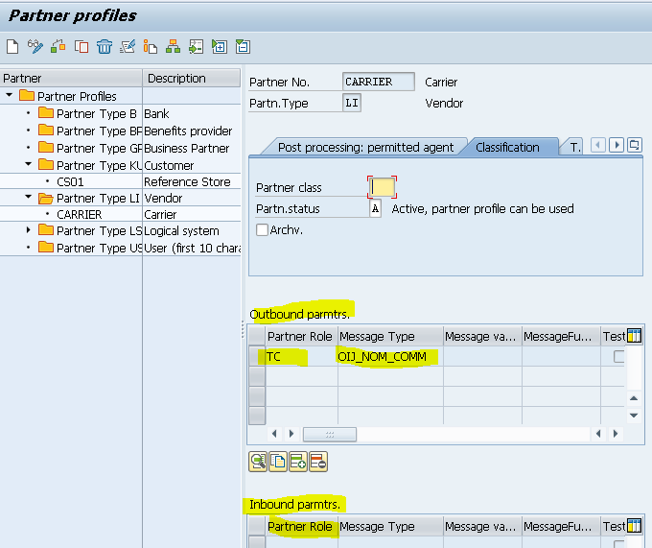

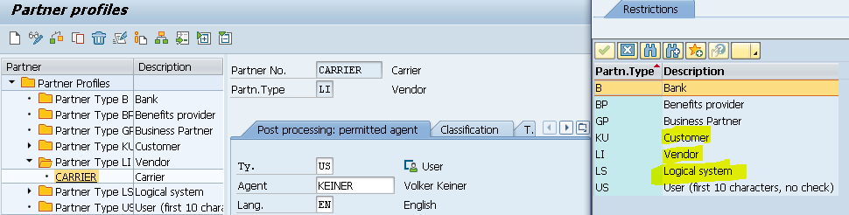

* **MESSAGE CONTROL (OUTBOUND PARAMETERS)( inbound parameters)**

Port means point with whom we are receiving (sender port) whom we are sending (receiving port)

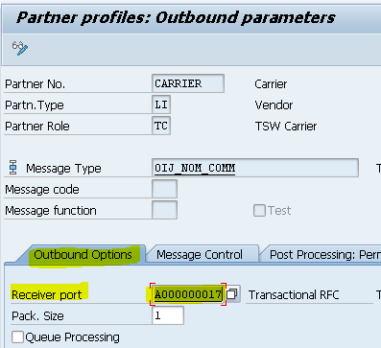

**Create idoc:WE30**

**Creating new idoc with existing idoc : we19**

**Documentation of idoc type of segments: WE60**

**( initially we should create the basic type ( idoc type) , idoc type contains the segments, After creating the basic type we should create the message type, we have to assign basic type to message type, after partner profile come into picture it will contains partner type and parameters of inbound and outbound, here we are assigning the message type if we double click that we can see receiver port or sender port ,**

**Idoc will generate based on output condition their we will link vendor or customer**

## The Outbound Process

**Steps Involved -n**

1. **Create segments(WE31)**
2. **Create an idoc type(WE30)**
3. **Create a message type (WE81)**
4. **Associate a message type to idoc type(WE82)**
5. **Create a port(WE21)**
6. **If you are going to use the message control method to trigger idocs then create the function module for creating the idoc and associate the function module to an outbound process code**
7. **Otherwise, create the function module or stand-alone program which will create the idoc**
8. **Create a partner profile(WE20) with the necessary information in the outbound parameters for the partner you want to exchange the idoc with.Trigger the idoc.**

## The Inbound Process

Steps Involved-

1. **Creation of basic Idoc type (Transaction WE30)**
2. **Creating message type (Transaction WE81)**
3. **Associating the Message type to basic Idoc type (Transaction WE82)**
4. **Create the function module for processing the idoc**
5. **Define the function module characteristics (BD51)**
6. **Allocate the inbound function module to the message type(WE57)**
7. **Defining process code (Transaction WE42)**
8. **Creation of partner profile (Transaction WE20)**

**`**

WE02 - Display IDoc

WE05 - IDoc Lists

WE09 - Search for IDocs by Content

BD87 : Release the idoc

**0-49** indicates an Outbound idoc and **50-75** as Inbound one.

**Sensitive fields for dual control:**

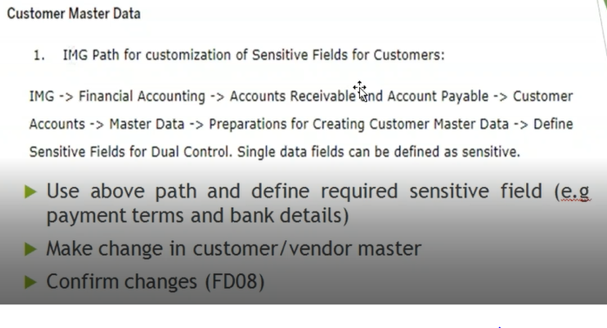

**How we are moving changes to one Clint to another**

**( TR moving)**

* **Identify the transport request which we have defined: SE09,SE10, SE01**
* **Copy the transport request : SCC1**
* **Type of transport requests**

**Workbench TR: workbench tr has cross Clint impact**

**Customizing TR: vice versa**

**SAP TABLES**

|  |  |
| --- | --- |
| **GL MASTERDATA** | |
| **Code** | **Description** |
| **SKA1** | **G/L Accounts (Chart of Accounts)** |
| **SKAT** | **G/L Accounts (Chart of Accounts: Description)** |
| **SKB1** | **G/L Accounts (Company Code)** |
| **Customer Master** | |
| **Code** | **Description** |
| **KNA1** | **Customer master** |
| **KNB1** | **Customer / company** |
| **KNVV** | **Customer sales data** |
| **KNBK** | **Bank details** |
| **KNVH** | **Customer hierarchy** |
| **KNVP** | **Customer partners** |
| **KNVS** | **Shipment data for customer** |
| **KNVK** | **Contact persons** |
| **KNVI** | **Customer master tax indicator** |
| **KNMT** | **Customer material info record** |
| **Vendor Master** | |
| **Code** | **Description** |
| **LFA1** | **Vendor master** |
| **LFB1** | **Vendor per company code** |
| **LFB5** | **Vendor dunning data** |
| **LFM1** | **Purchasing organisation data** |
| **LFM2** | **Purchasing data** |
| **LFBK** | **Bank details** |
| **Bank data** | |
| **Code** | **Description** |
| **BNKA** | **Master bank data** |
| **Accounting documents** | |
| **Code** | **Description** |
| **BKPF** | **Accounting documents** |
| **BSEG** | **Item level** |
| **BSID** | **Accounting: Secondary index for customers(open items)** |
| **BSIK** | **Accounting: Secondary index for vendors( open items)** |
| **BSIM** | **Secondary Index, Documents for Material** |
| **BSIP** | **Index for vendor validation of double documents** |
| **BSIS** | **Accounting: Secondary index for G/L accounts** |
| **BSAD** | **Accounting: Index for customers (cleared items)** |
| **BSAK** | **Accounting: Index for vendors (cleared items)** |
| **BSAS** | **Accounting: Index for G/L accounts (cleared items)** |
| **Payment Run** | |
| **Code** | **Description** |
| **REGUH** | **Settlement data from payment program** |
| **REGUP** | **Processed items from payment program** |
| **FI document** | |
| **Code** | **Description** |
| **T010O** | **Posting period variant** |
| **T010P** | **Posting Period Variant Names** |
| **T001B** | **Permitted Posting Periods** |
| **T003** | **Document types** |
| **T012** | **House banks** |

FAGLFLEXT - Leading Ledger

FAGLFLEXA - Ledger Specific postings

FAGLFLEXT is a Totals table where you see the balances as per the GL for both Leading and Non-Leading ledger. Displays GL wise totals.

FAGLFLEXA is a Line items table where you see the line items. Displays actual line items

BSEG_ADD is Entry View of Accounting Document for Additional Ledgers.

**RBKP:** **Document Header: Invoice Receipt**

**Master data tables:**

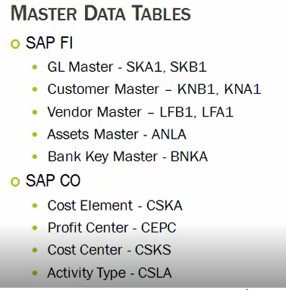

**Transactional data:**

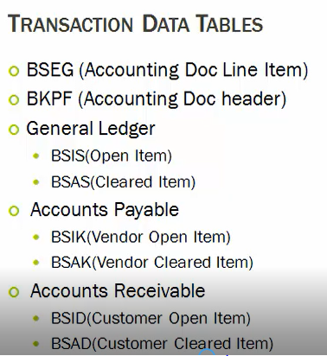

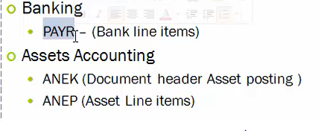

**MM**

MBEW-Material Master Accounting Data

MARA - Material Master Table

MARC - Plant Material Data

MARO - Company Material Data

MAKT - Material Text Table.

MARD- Storage Location data in MMR

Sales order:

1. VBAK Header data
2. VBAP Item data

Billing document:

1. VBRK: header data
2. VBRP: Item data

Purchasing:

1. EKKO Purchase document
2. EKPO Purchase document (item level)
3. EKBE

You can see all the background jobs scheduled in table TBTCS.

The status of the background jobs can be checked in TBTCO

Information of the cancelled job can be seen in SM37

**Day end and Month end & Year end activities:**

**Day end activities:**

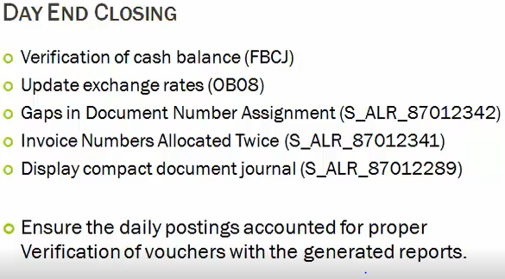

**Month ends:**

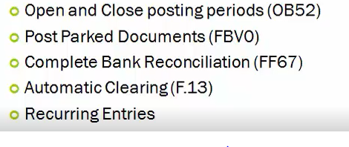

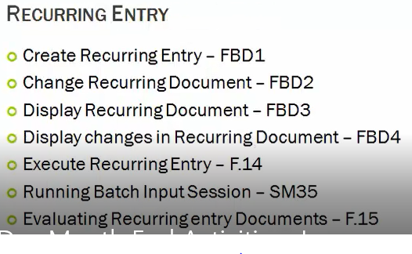

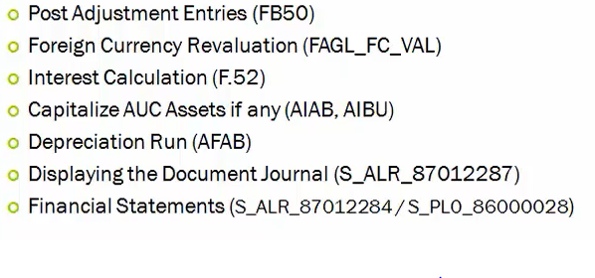

1. **Depreciation run**
2. **Period close and open**
3. **Gr/ir clearing**
4. **Foreign currency revaluation**
5. **Financial statement generation**
6. **Recurring entries posting**

**Year-end activities :**

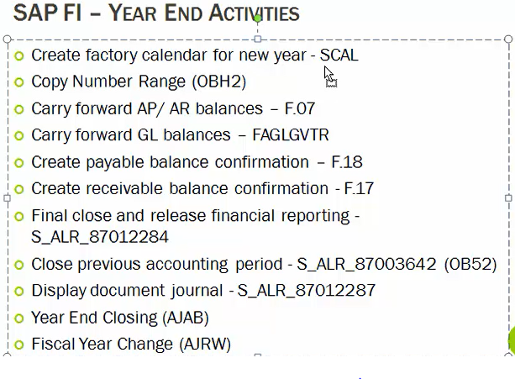

**SE38: ABAP editor (for creating variants)**

**SM36: job scheduling**

**Sm37: overview of job selection**

**SM35: batch input session**

**S/4 HANA Changes**

* Totals index tables were removed (exist as views) and theses are replaced by the Universal journal ACDOCA table.
* [ACDOCA](https://skillstek.com/universal-journal-in-sap/) is the Universal Journal Table. This table contains data for Leading Ledger, Non-Leading Ledger, Simulation Ledger, and Prediction Ledger, etc.
* This table provide the all information like CO, AA and other cost object information in one table so there is no reconciliation involved
* An additional column appears in Transaction OB52 (Opening and closing periods) for postings from Controlling to Finance, although still, OKP1 required at the CO area level.
* Now, Finance and Controlling are merged to avoid data duplicity and the need for reconciliation.
* GL account and Cost Element are merged together. Cost element categories now available in GL account master.
* In ECC there used to be up to 3 parallel currencies in FI, T-code: OB22, where as in Hana 8 freely defined additional currencies (total 10)
* FK01 and XD01 is now not in used. Now need to create vendor using BP ( Business Partner ) creation role.
* Credit Management now with FSCM , Other than creating the credit controlling area, need to define credit segments and assign it to BP role.
* Now credit limit we have maintaining in BP level, not in controlling area level.
* FAGL_FCV screen has extra options like test run, simulation run, and update run.
* Now in s/4 hana house bank creation considered as master data.

**Asset changes**

* new Asset accounting will provide parallel valuation. The leading valuation can be recorded in any depreciation area. The system now posts both the actual values of the leading valuation and the values of parallel valuation in real time.
* For an integrated asset acquisition posting, the system divides the business transaction into an operational part and a valuating part.

Operational part entries

DR Technical clearing

CR Vendor

Valuation part

DR Asset

CR Technical clearing

* Simplified the depreciation run (AFAB) there is no repeat and rerun options
* There is no separate balance carry forward needed in asset accounting, the general ledger balance carry forward transaction FAGLGVTR transfers asset accounting balances.
* The program Fixed Assets-Fiscal Year Change transaction AJRW is no longer has to be performed at fiscal year change.

**Controlling:**

**Controlling Area:** **The controlling area is the highest organizational level within CO,** **A controlling area may include single or multiple company codes that may use different currencies. These company codes must use the same operative chart of accounts and fiscal year should be same.**

**All internal allocations refer exclusively to objects in the same controlling area.**

* Define controlling area :OKKP
* **Maintain number range for controlling area: KANK**
* **Maintain version in sap controlling: OKEQ**

**COST ELEMENT ACCOUNTING:**

**Cost Elements track the type of costs or spend. Cost element accounts provides with an overview of revenue and cost occur in an organisation, It will help management to track costs according to internal accounting policies, cost element are divided in to two parts one is primary and another one is secondary .**

**Cost element we can restrict to particular period.**

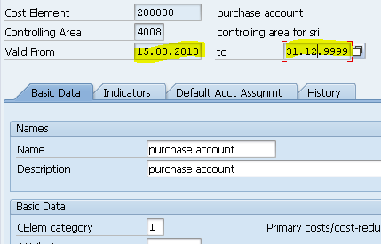

Primary cost element: **primary cost elements are cost carriers between fi and co the link is established GL A/c = Cost element (Primary). A question may arise as to whether all GL accounts are cost element, it again depends upon the business requirement, where COPA is active then revenue account (GL) are also cost elements, where COPA is not active then revenue account (GL) should not be made as an cost element.**

**Example....**

**Again cost of goods sold particularly in VAX (make to stock) is not an cost element, where the same COGS in VAY (make to order) is a cost element. Price Difference account should not be made as cost element.**

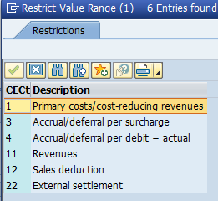

**Secondary cost element: When cost element carries cost with in CO, then they are called secondary cost element.**

Example.... - Take Product Costing

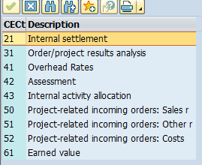

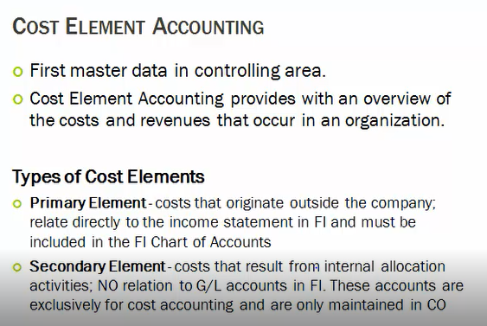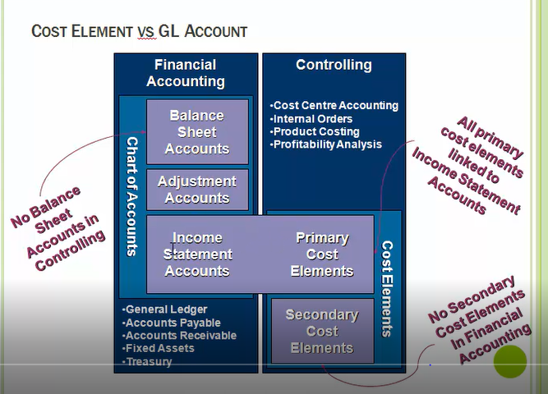

Cost centre Accounting

* **Cost Center is sub unit of company and it is responsible for cost, cost center Accounting is used to identify the costs incurred by an organization, Costs are tracked by individual areas of the organization called cost centers.  Cost centers have responsibility for controlling costs**
* **Cost centers can plan future costs to have a basis for comparison with actual costs.  This provides a means of measuring the cost center's performance in controlling costs**
* **All cost centers must appear somewhere in the controlling area's "standard hierarchy"**
* **If business areas are active in FI, each cost center must be assigned a business area**
* **All work centers in PP must be tied to a cost center, for this is where activities and prices are planned**
* **Statistical key figures can be posted to cost centers; these are used in reporting and allocations**
* **Cost centers can be planned and/or budgeted (plan is pie-in-the-sky; budget is based on control)**

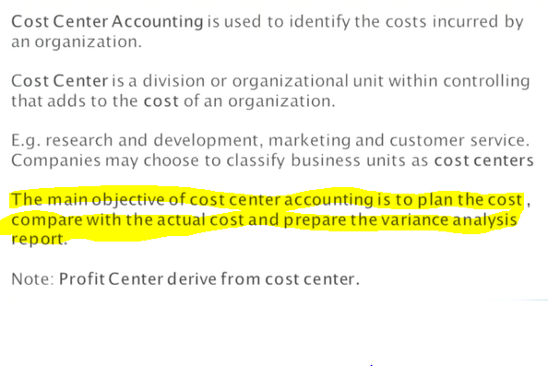

* Define cost centre hierarchy :OKEON

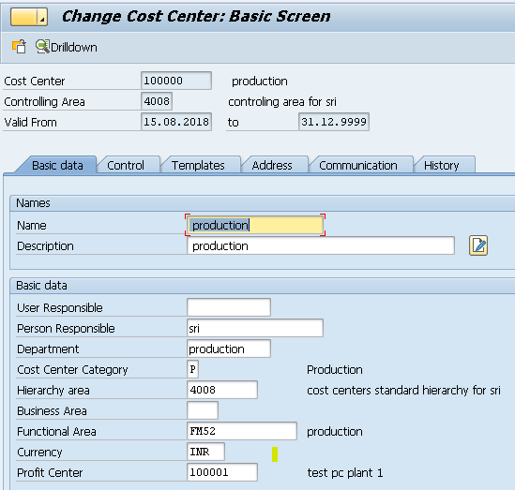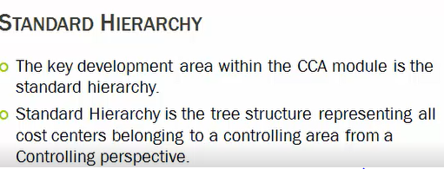

* Create Cost center categories : OKA2

**Based on cost center category we can get to know whether this cc is for which department like finance or production or sales**

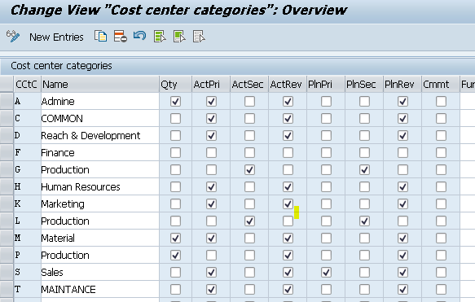

**Cost center planning:**

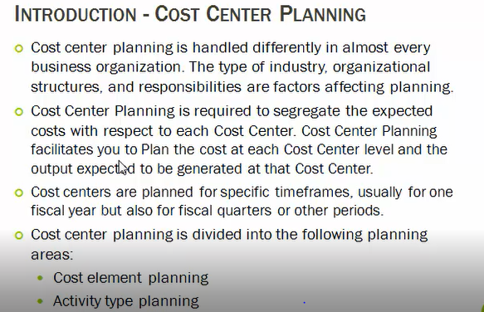

* **Define version : OKEQ**
* **Define planning layout: KP65**
* **Defining planning profile : KP34**

**Activity type**

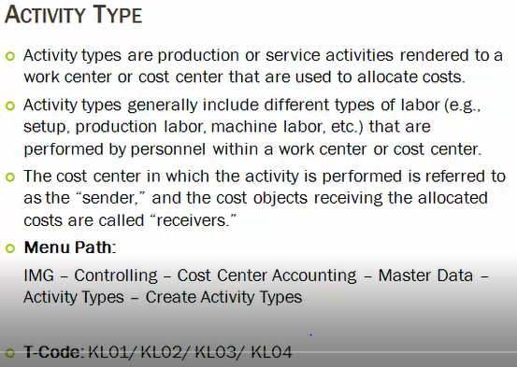

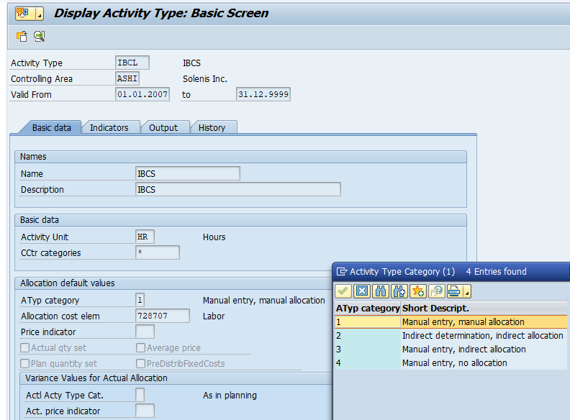

**Statistical key figure**

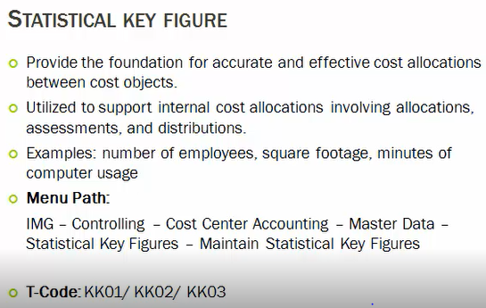

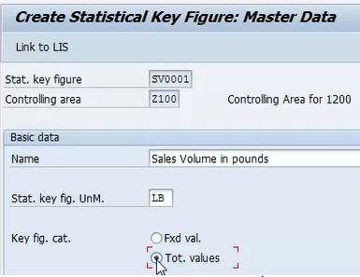

profit center:

A profit center is a subunit of a company that is responsible for [revenues](https://www.accountingcoach.com/blog/what-are-revenues) and costs, profit center we are used to identify cost and revenue incurred in perticular unit,

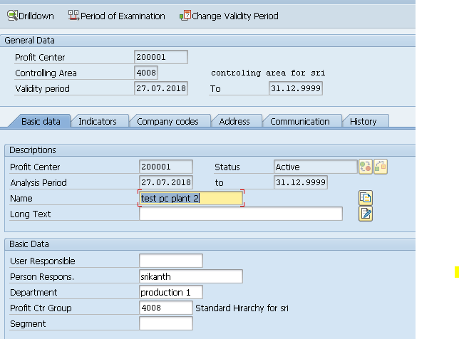

Internal order:

**Internal orders are used to track overhead cost incurred for a specific project,**

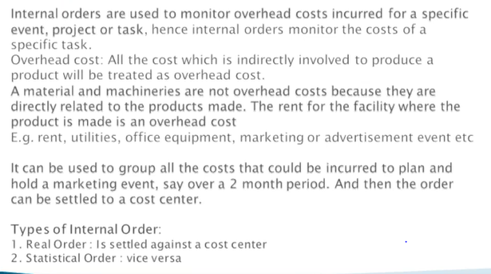

**Cost objects:**

**Cost Center**

**Internal Order**

**Production/Process Order**

**Sales Order**

**WBS Element**

**profitability segment**

**Difference between cost center, WBS element, and Internal order**

|  |  |  |  |
| --- | --- | --- | --- |
| **Features** | **Cost center** | **WBS element** | **Internal order** |
| Focus | Ongoing operations | Project tracking | Specific task / events |
| Timeframe | Continuous | Temporary project based | Temporary |
| Hierarchical Structure | Flat | WBS Tree | Flat |
| Control level | Departmental | Project manager | Task/ event |
| Budget / cost control | Broad level | At project level | Specific assignment |

**Projects**

* **Implementation**

**In implementation I have joined on Realization stage and i have mainly worked on below areas**

**FI-mm and FI-SD integration**

**WHT configuration**

**Fx settings**

**FBZP & maintaining IDOC structure**

**FBMP**

**EBS**

* **Support**

**Incidents:**

**p1: 3 hours**

**p2: 1 day**

**p3: 3 days**

**p4: 1 week**

**Problem tickets: if any configuration is not working as expected we will raise problem and contact SAP through raising OSS**

**Tasks : not related to bugs , if any new enhancement**

**Change requests : to present changes in cab we will create change request with revtrack numbers ( we are tracking transport requests in one revtrack and presenting in meeting, for better understand and approval process)**

* **Treasury management system**
* **All the payment bank interfaces are being migrated from traditional Web Methods to Dell Bhoomi with inclusion of Open text and Swift (for applicable bank partners)**
* **Regions Covered – NA, EMEA and APAC (LATAM is out of scope for this phase)**
* **Format of the payment file getting delivered to bank (IDOC to XML)**
* **Customized tcode for releasing idocs ( Zpayfile_send),** **Payment file release functions in SAP**
* **Customized tcode to view the payments status (Zpay_Bank_Status)**
* **Customized tcode for reversing ZP documents( Zfbra),** **Reset and reverse functionality – Mass**
* **Implementation of some master data level changes for specific payment types**
* **Opentext VIM upgrade**
* **Upgrading icc to ic4s 16.7**
* **Upgrading VIM 7.0 to 7.5 SP 10**
* **Rollout to new company code**
  1. **Maintaining the business center capture**
  2. **Maintaining the archive procedure**
  3. **Maintaining the document types**

**VIM process explanation**

Receiving the invoices to generic email boxes from suppliers

Robo will pick the invoice from email box and scan in respective country and po/npo

Image will archive and work id will create, and extraction will complete based on IC4S and it will sit on validation stage

User need to train the system by doing the validation, so that next time system will pic data from same stage

Once validation is submitted it will route to VIM workplace for processing.

Based on roles user can view the dp documents

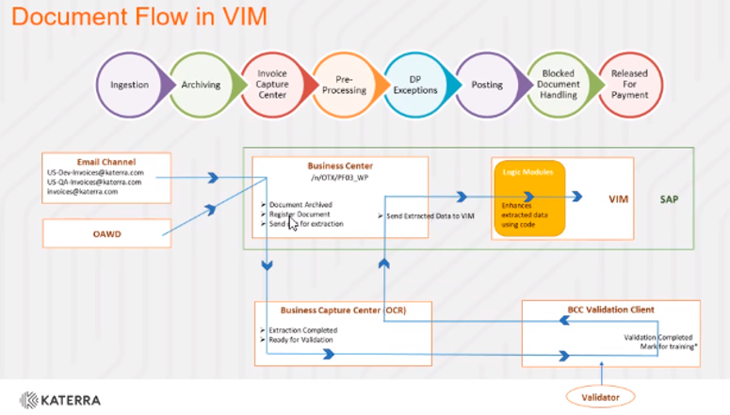

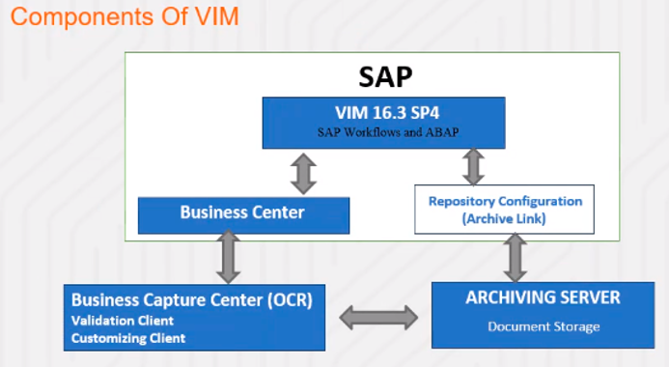

**Archiving and business center configuration flow**

**VIM configuration**

**FSCM**

**Bank Communication Management:**

BCM stands for Bank Communication Management, which is a component under FSCM (Financial Supply Chain Management). BCM is responsible for communication with a bank in terms of payments sent, acknowledgments received and approval workflows before payments are sent to the bank. Having said that BCM does not send payment files to banks. It’s a middleware that picks up the file, encrypts it, and sends it to the bank. BCM is responsible for the grouping of payments, merging of batches, approvals for batches, and generating the payment batch. These batches get updated in the bank monitor. Upon receiving responses/acknowledgments from the bank, the bank monitor gets updated with appropriate status. In short, bank monitor is your single source of truth for payment batches.

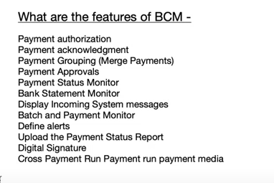

**Configuration steps**

* Make sure the workflow templates and tasks are assigned as general task. To do so call transaction PFTC. Update task type and task. Click on edit to update this task as general task. If this is not maintained as general task, you will not be able to see your batch in bank monitor(BNK_MONI/BNK_MONIP).

**Benefits of BCM**

SAP Treasury Management with Bank Communication Management (BCM):

facilitates payment status management and bank statement monitoring within SAP S/4HANA. It provides features for monitoring payment statuses, managing bank statements, and ensuring compliance with banking regulations. This allows businesses to streamline their banking processes and gain greater visibility into their financial transactions.

Payment Status Management:

* Payment Status Monitor:

Tracks the status of payments from creation to payment. This includes monitoring incoming status messages from SWIFT and banks.

* Batch Creation and Approval:

Allows users to group payments into batches and implement workflow-based approval processes before payment processing.

* Digital Signatures:

Facilitates digital signatures for payment approvals, providing an audit trail and enhancing security.

Bank Statement Monitoring:

* Bank Statement Monitor:

Displays the status of bank statements from individual bank accounts, allowing users to track differences between the bank statement and G/L account balances.

* Reconciliation Status:

Provides information on the reconciliation status of bank statements, helping to identify any discrepancies.

* Reporting and Analytics:

Offers reports and analytics on incoming and outgoing communications, providing visibility into payment flows and bank statement import status**.**